Activity based on information found in the following document: Sayers, A. T. (2007). Critical Analysis of Sunshine Skyway Bridge. *Proceedings of Bridge Engineering 2 Conference.* Bath, UK: University of Bath.

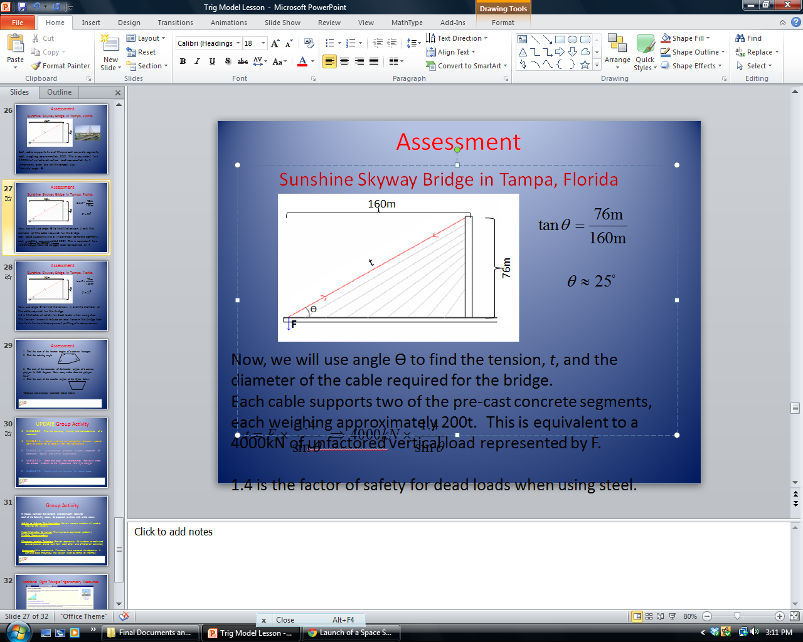

**Calculate angle Ɵ and use it to find the tension, *t*, and the diameter of the cable required for the bridge.**

1. Calculate angle Ɵ.

2. Given: Each cable supports two of the pre-cast concrete segments, each weighing approximately 200tons. This is equivalent to a 4000kN of unfactored **vertical** load represented by *F*. 1.4 is the factor of safety for dead loads when using steel. (Sayers, 2007) Use angle Ɵ to find the tension, *t,* of the cable required for the bridge using the following formula.



3. This tension force will induce an axial force in the bridge deck due to its **horizontal** component putting it into compression. Calculate the horizontal component (*N*) using the following formula.



4. A high tensile steel tendon with a yield strength of $1650N/{mm}^{2}$ was chosen to be used. The area (*A*) of the steel required can be calculated by dividing *t* (refer to question #2*)* by the strength of the steel tendon. Find the area of the steel cable that’s required to support the bridge.

5. Find the diameter of the steel cable that’s required to support the bridge.