**[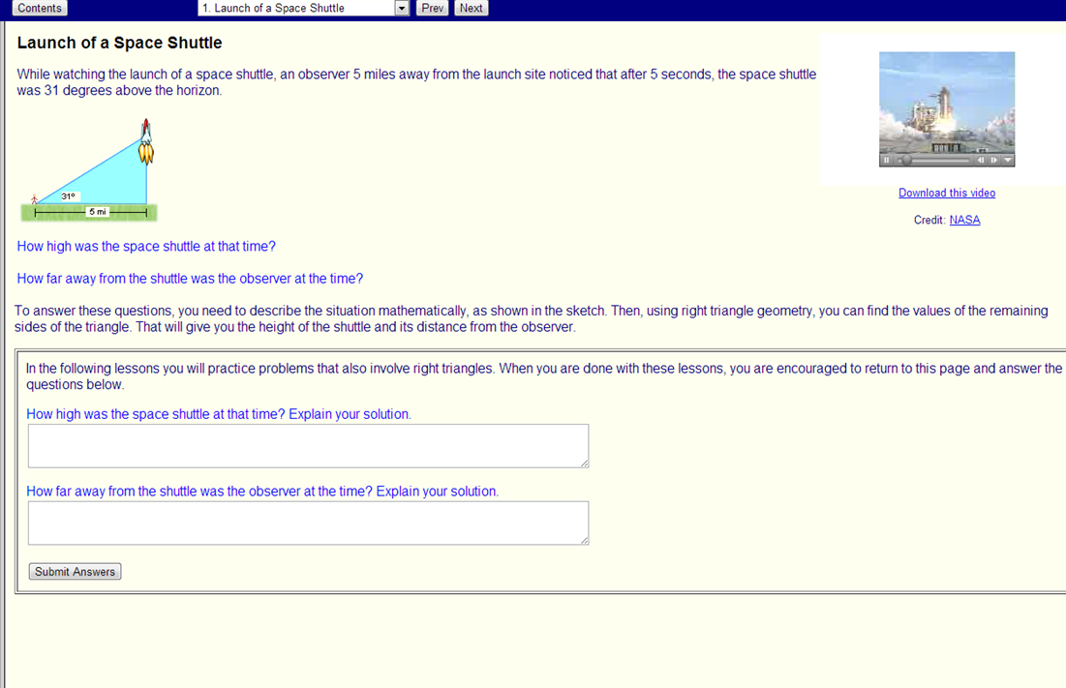](http://enlvm.usu.edu/ma/nav/activity.jsp?sid=__shared&cid=emready@right_triangles&lid=1)**[**MACC.912.G-SRT.3.7:**](http://www.cpalms.org/Standards/PublicPreviewBenchmark5617.aspx) **Explain and use the relationship between the sine and cosine of complementary angles.**[**MACC.912.G-SRT.3.8:**](http://www.cpalms.org/Standards/PublicPreviewBenchmark5618.aspx) **Use trigonometric ratios and the Pythagorean Theorem to solve right triangles in applied problems.**

Launch of Space Shuttle: While watching the launch of a space shuttle, an observer 5 miles away from the launch site noticed that after 5 seconds, the space shuttle was above the horizon.

How high was the space shuttle at that time? How far was the observer from the space shuttle at that time? (Round to nearest hundredth.)

Source: <http://enlvm.usu.edu/ma/nav/activity.jsp?sid=__shared&cid=emready@right_triangles&lid=1>

**Fill in the blank to make a true statement.**

1. sin= cos _____ 2. sin= cos _____

3. cos= sin $°$_____ 4. cos $81°$ = sin $°$

_____

**Solve the triangles. (Round to nearest tenth.)**



7. Find the height of the tree. (Round to nearest hundredth.)

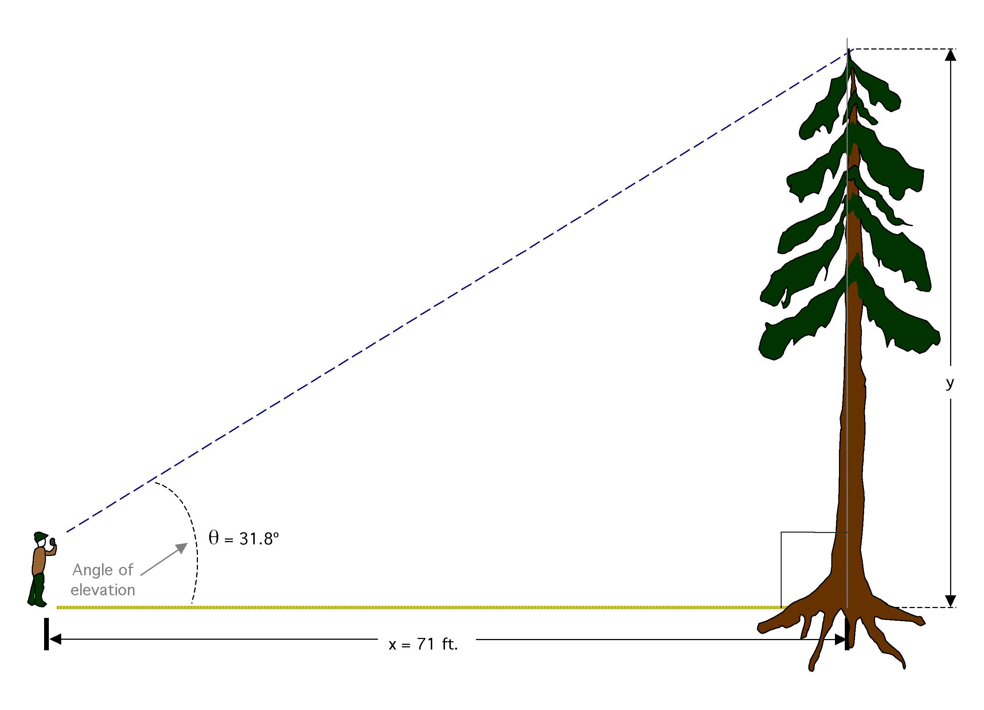

84 ft.



Adapted from <http://www.tiem.utk.edu/~gross/bioed/bealsmodules/triangle.html>

8. Find the angle of elevation from the person on the ground to the plane (shown as “*A*” in the diagram). (Round to nearest tenth of a degree.)



4200m

3000m



A