**[MACC.912.G-SRT.3.6:](http://www.cpalms.org/Standards/PublicPreviewBenchmark5616.aspx) Understand that by similarity, side ratios in right triangles are properties of the angles in the triangle, leading to definitions of trigonometric ratios for acute angles.**[**MACC.912.G-SRT.3.7:**](http://www.cpalms.org/Standards/PublicPreviewBenchmark5617.aspx) **Explain and use the relationship between the sine and cosine of complementary angles.**[**MACC.912.G-SRT.3.8:**](http://www.cpalms.org/Standards/PublicPreviewBenchmark5618.aspx) **Use trigonometric ratios and the Pythagorean Theorem to solve right triangles in applied problems.**

1. Using the grid, find the lengths of sides and  . Label them on the diagram below.

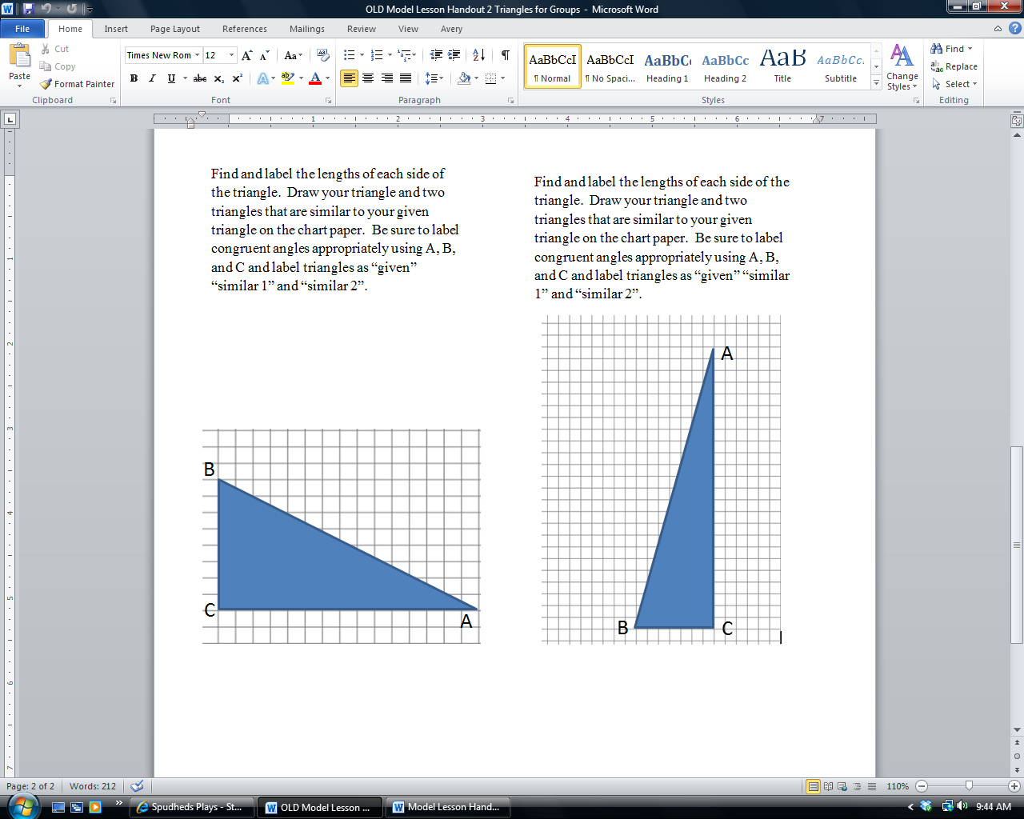

2. Use a protractor to measure angle C and record answer. _____________

3. Find the length of side . Justify your answer two ways. _____________________________

________________________________________________________________________________________________________________________________________________________________________________________________________________________________________________

________________________________________________________________________________

4. Draw the triangle pictured above and two triangles that are similar to the given triangle on the chart/grid paper. Be sure to label congruent angles appropriately using A, B, and C and label triangles as “given” “similar 1” and “similar 2”. Label the lengths of each side (as measured on the grid).

5. Complete the table for the three triangles that are drawn on your chart paper. Express as ratios in simplest fraction form.

|  |  |  |  |
| --- | --- | --- | --- |
|  |  |  |  |
| Given triangle |  |  |  |
| Similar 1 triangle |  |  |  |
| Similar 2 triangle |  |  |  |

6. Use a protractor to find the measure of angle A (to the nearest degree) in all three triangles.

___________

7. Find the measure of angle B without using a protractor. Justify your answer. _______________

________________________________________________________________________________

8. Complete the statement: When the sum of two angles is, the angles are called __________________________ angles.

9. Repeat the process for Angle B. Complete the table for the three triangles that are drawn on your chart paper. Express as ratios in simplest fraction form.

|  |  |  |  |
| --- | --- | --- | --- |
|  |  |  |  |
| Given triangle |  |  |  |
| Similar 1 triangle |  |  |  |
| Similar 2 triangle |  |  |  |

10. Predict the following ratios with respect to angle A for any triangle similar to the given triangle.

  

11. Predict the following ratios with respect to angle B for any triangle similar to the given triangle.

  

**The ratios of the lengths of two sides of a right triangle are known as trigonometric ratios. The three trigonometric ratios that you found in this activity are sine, cosine, and tangent.**

They are defined as follows:

  

12. Complete the statements based on your observations of the ratios of similar triangles.

For all triangles with your given angle measurements,

* The sine of the smaller acute angle (____) is the ratio _______≈_______ (expressed as decimal rounded to two decimal places).
* The cosine of the smaller acute angle (____) is the ratio _______≈_______ (expressed as decimal rounded to two decimal places).
* The tangent of the smaller acute angle (____) is the ratio _______≈_______ (expressed as decimal rounded to two decimal places).
* The sine of the larger acute angle (____) is the ratio _______≈_______ (expressed as decimal rounded to two decimal places).
* The cosine of the larger acute angle (____) is the ratio _______≈_______ (expressed as decimal rounded to two decimal places).
* The tangent of the larger acute angle (____) is the ratio _______≈_______ (expressed as decimal rounded to two decimal places).

13. Use a scientific or graphing calculator to verify your answers. Round to 2 decimal places.

**Record the information below and post to share with your peers.**

**sin ____(smaller acute angle) = _____ sin ____(larger acute angle) = _____**

**cos ____(smaller acute angle) = _____ cos ____(larger acute angle) = _____**

**tan ____(smaller acute angle) = _____ tan ____(larger acute angle) = _____**

14. Based on your observations of the values of the trigonometric ratios of similar triangles, answer the following questions about right triangles.

a. Do you need to be given the dimensions of a right triangle to determine the values of sine, cosine, and tangent of a given angle? Explain your answer.

________________________________________________________________________________________________________________________________________________________________________________________________________________________________________________

b. If you are given the measurements of the sides of a right triangle, do you need to be given the angle measures to determine the values of sine, cosine, and tangent? Explain your answer.

________________________________________________________________________________________________________________________________________________________________________________________________________________________________________________

c. Find the measure of angle Ɵ given the equation: . Explain your answer and verify using your calculator.

________________________________________________________________________________________________________________________________________________________________________________________________________________________________________________

d. Find the measure of angle Φ given the equation: . Explain your answer and verify using your calculator.

________________________________________________________________________________________________________________________________________________________________________________________________________________________________________________

e. Find the measure of angle given the equation: . Explain your answer and verify using your calculator.

________________________________________________________________________________________________________________________________________________________________________________________________________________________________________________

15. Examine your answers to #13. Then, walk around and look at the work of your classmates as they post it. It’s important to examine more than one triangle before drawing a conclusion. Look for a relationship between some of the trigonometric values. Do any of them have the same value? If so, what is the relationship between the angles? Make a hypothesis regarding these types of angles. Test your hypothesis and record your work below. Is your hypothesis correct? Justify your answer.

________________________________________________________________________________________________________________________________________________________________________________________________________________________________________________

________________________________________________________________________________________________________________________________________________________________________________________________________________________________________________

________________________________________________________________________________________________________________________________________________________________________________________________________________________________________________

________________________________________________________________________________