**Solve.** (Round answer to 3 decimal places.)

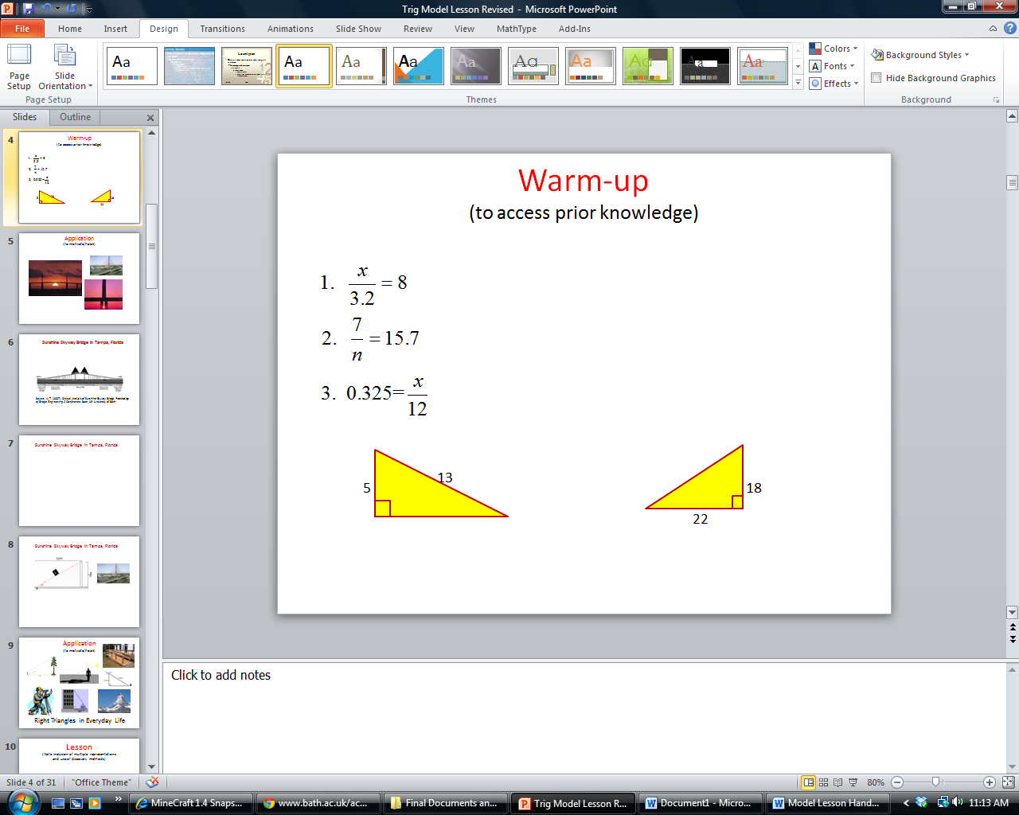

5.

4.

**Find the missing side.** (Round to 2 decimal places.)

Warm-up

**Solve.** (Round answer to 3 decimal places.)



5.

4.

**Find the missing side.** (Round to 2 decimal places.)