Introduction to the
Coastal Ecosystem Curriculum
The Gulf of the Farallones is a dynamic coastal region with a very rich biological community. Many high school students living less than 20 miles from the Pacific coast are unaware of this complex and unique ecosystem located just outside of the Golden Gate. This Coastal Ecosystem Curriculum provides activities and a monitoring project to engage high school students in learning about the marine environment in their backyard.
This curriculum focuses on the coastal ecosystem in the Gulf of the Farallones. Birds, the sandy beach, and oceanographic currents are all connected in this ecosystem. One goal of this curriculum is to teach high school students about the natural connections in the ecosystem and how humans fit into the ecosystem. Sand crabs, the focus of the monitoring project, are prey for birds yet sometimes they carry parasites or domoic acid from plankton which can injure and kill birds. Oil spills can impact all organisms, and it is the oceanographic conditions that move oil and plankton. By understanding the connections in the Gulf of the Farallones, high school students can develop skills to become stewards of the ocean.
The water surrounding the Farallon Islands off the California coastline is protected and managed by the Gulf of the Farallones National Marine Sanctuary (NMS). Designated in 1981, the Sanctuary consists of offshore marine regions of the Gulf of the Farallones and the water up to the high tide line from Bodega Bay to Rocky Point. Of the thirteen National Marine Sanctuaries, San Francisco Bay residents are lucky to have three Sanctuaries protecting the coastal water so close to their homes. Cordell Bank NMS borders to the north and west of the Gulf of the Farallones NMS and Monterey Bay NMS protects the waters bordering the Gulf of the Farallones NMS south to Cambria.
The geological landscape under the water sets the scene for the Gulf and impacts the flow of the water. The Gulf of the Farallones is on the continental shelf, with the steep continental slope less than 30 miles from the shoreline. Seasonal winds drive currents and mixing, resulting in three oceanographic seasons. The life cycles of the animals living in the region are tied to the oceanographic conditions.
The upwelling season of spring and summer is driven by the northerly winds. In the activity entitled “Coastal Ocean Upwelling,” students will examine real oceanographic data and observe how surface winds impact the Gulf of the Farallones. Cold, nutrient rich water is brought to the surface by the upwelling of deeper water. Phytoplankton use the upwelled nutrients along with the sunlight in photosynthesis and growth to form the base of the region’s food web. From phytoplankton to zooplankton to fish, birds, and marine mammals, the energy is transferred from one trophic level to the next. There is great biological diversity and abundance – 36 species of marine mammals, more than 300,000 seabirds, and 30 endangered and threatened species – in the Gulf of the Farallones. In the Food Web unit, students learn about the connections between the trophic levels of the open waters of the Gulf of the Farallones, while in the Sandy Beach unit they examine coastal animals.
In the late summer and early fall, the winds die down and upwelling stops. This is called the relaxation period. Many marine mammals such as humpback and blue whales migrate to the region to feed on the abundant zooplankton krill during the summer and fall. The abundant seal population around the Farallon Islands attracts one of the largest concentration of white sharks in the world during the fall. Other animals, such as gelatinous zooplankton, also become very abundant during this season.
Beginning in November, winter storms dominate the region. The ocean water is well mixed, moving phytoplankton deeper, into darker water and reducing their growth. Sandy beaches change shape as the rough waters transport sand and sand crabs offshore. Students can measure the shape of beach slope as described in the Beach Profile Survey activity to see seasonal changes. The winter storm season lasts until about February when the strong northerly winds begin again and the cycle starts over with spring upwelling.
Students can make their own discoveries and become stewards of the marine environment through their involvement in the monitoring program. Included in this curriculum is a handbook for monitoring the sandy beach habitat. Pacific mole crabs (Emerita analoga), also called sand crabs, live in the swash zone of the sandy beaches along the Pacific coast. They are prey for fish, seabirds, shorebirds, and sea otters, and carry parasites that can affect these predators. Sand crabs feed on plankton, some of which produce the toxin domoic acid that can also affect these predators. In this project, students can use their understanding of the Gulf of the Farallones ecosystem and apply it to the sandy beach habitat. Students will monitor the abundance and distribution of sand crabs to establish a long-term baseline dataset to help access the health of the sandy beach habitat.
The Gulf of the Farallones is juxtaposed to the San Francisco Bay metropolitan area where 8 million people live. Waste and other pollution from cities are washed into the Gulf through the Sacramento and San Joaquin rivers and streams that drain into San Francisco Bay. Major shipping lanes run through the Gulf of the Farallones National Marine Sanctuary. Oil pollution is not just a threat but a reality. Small spills are common, and large spills are not rare. In 1984, 1.4 million gallons of oil were released into the Gulf of the Farallones by the Tanker Vessel PUERTO RICAN. In the Oil Spill unit, there are activities about this particular oil spill and how oil spills are cleaned up.
How to Use the Curriculum
This curriculum was designed for high school classrooms in the San Francisco Bay Area. These activities can be used in marine science, biology, and environmental science classes. Each classroom or science club is different, so by providing many activities and suggestions, we hope that each teacher uses the pieces of this curriculum that work for them and their students.
Section of the Coastal Ecosystem Curriculum
Gulf of the Farallones and Cordell Bank National Marine Sanctuaries
Oceanography of the Gulf of the Farallones
Food Web of the Gulf of the Farallones
Sandy Beaches of the Gulf of the Farallones National Marine Sanctuary
Oil Spills in the Gulf of the Farallones
Sandy Beach Monitoring Project: Teacher Handbook

For other units, go to www.farallones.org
It is recommended that all students are introduced to the Sanctuary, the seasons of the Gulf of the Farallones, the sandy beach habitat, and oil spills. One option is to present the Gulf of the Farallones NMS slide show followed by the Coastal Ocean Upwelling activity, then present the sandy beach slide show, map the T/V PUERTO RICAN, and conduct the Spilled Oil activity. If students participate in the monitoring project, it is important to introduce them to the Sanctuary and the sandy beach habitat during the project.
Organization of Curriculum and Activities
The background text at the beginning of each unit provides teachers with fundamental information. Each unit has several activities to choose from. The activities are linked to the California State Standards and include objectives, materials needed, and step-by-step procedures. The fact sheets and student worksheets are intended for teachers to reproduce for their students. Slide shows are available to rent from the Farallones Marine Sanctuary Association. Glossary words are italicized in the slide shows and background information.
Feedback and Evaluation
This is the first draft of the curriculum. We welcome all suggestions and comments – what worked, what didn’t work, what is missing, and how to improve the curriculum for other teachers and students. Please fill out the Feedback and Evaluation Form at the end of this section or contact Jennifer Saltzman at jsaltzman@farallones.org or (415) 561-6625.
Funding
The Coastal Ecosystem Curriculum and Coastal Ecosystem Teacher workshop are funded in part by the T/V
PUERTO RICAN Oil Spill Restoration Fund through the Gulf of the Farallones National Marine Sanctuary.
Credits
This curriculum could not have been developed without the help of many people. Thank you to Sue Magdziarz, Maria Brown, and Jan Roletto who have read and critiqued every activity and slide, helping to make this a reality. Thanks also go to the rest of the Farallones Marine Sanctuary Association, Gulf of the Farallones NMS, and Cordell Bank NMS staff who contributed their knowledge, ideas, and love of the Sanctuary.
For the Oceanography Unit, Toby Garfield at San Francisco State University contributed to the Coastal Ocean Upwelling activity and Jerry Norton of the Pacific Fisheries Environmental Group contributed some of the graphs. Marlene Noble of the United States Geological Survey helped with stray questions about the geology of the region. Thanks to Ed Carpenter at San Francisco State for lending us slides. Thank you to all the photographers for their slides.
Thanks to all,
Jennifer Saltzman, Ph.D. Education Coordinator
Farallones Marine Sanctuary Association

Food Web of the Gulf of the Farallones
Teacher Background Information

In all habitats on Earth, individual organisms interact with other organisms and are influenced by their environment. The study of these processes is the science of ecology. In the marine environment, the ecology of the nearshore and coastal waters has been well studied because of their accessibility, while the deep sea and offshore regions are not as well understood. In this brief review, trophic dynamics, biochemical cycles, and population ecology will be discussed in reference to the Gulf of the Farallones.

Trophic Dynamics and Biochemical Cycles
In most ecosystems, primary producers use photosynthesis to capture energy for life. The energy is used for growth and maintenance and is passed on to other organisms. Primary producers, or autotrophs, combine inorganic chemicals with energy from sunlight to produce energy-rich organic compounds, such as sugar. Consumers, or heterotrophs, depend on primary producers for their nutritional and energetic requirements.

Organisms can be grouped into trophic levels, depending on where they get their energy. Primary consumers eat primary producers, secondary consumers eat primary consumers, and tertiary consumers eat secondary consumers. Both energy and matter are passed along from one trophic level to the next, but it is rarely a simple progression. Most predators feed at multiple trophic levels and take advantage of feeding opportunities when they arise. Most ecosystems, both terrestrial and marine, are quite complex, even the apparently simple ones. An important link in ecosystems that is often overlooked is the decomposers. They consume waste and dead organisms, recycling matter back into inorganic chemicals. This completes the cycle by providing the primary producers with the inorganic chemicals they require for growth.

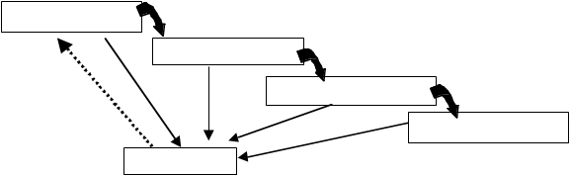
Inorganic Chemicals
Decomposers
Tertiary Consumers
Secondary Consumers
Primary Consumers
Primary Producers

In the marine environment, algae form the foundation to support growth at the higher trophic levels. Most of the single-celled algae are phytoplankton, freely floating in the surface layers of the water. Some single-celled algae live on the sediment and rocks. The next trophic level is the grazers which vary in different marine habitats. In the open water, zooplankton and filter-feeding fish graze on phytoplankton. On the rocky shores, snails and limpets graze on attached algae. Carnivorous zooplankton and sea stars are examples of secondary consumers. Baleen whales can also be classified as secondary consumers, because they eat the grazing zooplankton. Large fish and birds typically feed at higher trophic levels, yet are known to eat zooplankton also. In the ocean, there are bacteria which decompose the dead organisms.

There are usually complex interconnections between various trophic levels in an ecosystem. Consumers rarely eat only one food source. A good example of this is the blue rockfish (Sebastes mystinus), one of the most abundant nearshore rockfish in the Gulf of the Farallones. During most of the year, they feed on gelatinous zooplankton. In the spring when juvenile rockfish move into the nearshore habitat, adult blue rockfish feed on them. When food is scarce, the blue rockfish feed on the reproductive sori of the bull kelp, a large algae.

A food web is used to describe the relationships between species in an ecosystem. Upwelling regions such as the Gulf of the Farallones have shorter food webs in comparison to the open ocean ecosystems. There are fewer species at each level and fewer trophic levels in the upwelling food web, yet the upwelling region is much more productive. Diatoms are the dominant primary producers in the Gulf of the Farallones. Krill, more formally called euphausiids, are one of the most important primary consumers. Many species of fish, birds, and baleen whales migrate to the Gulf each summer to feed on the dense aggregations of krill. Salmon and other large fish eat the smaller herring and anchovies in addition to krill during some seasons. Party boat skippers look for feeding seabirds to help them find salmon feeding on the same krill. In addition to these in the pelagic habitat, organisms in the nearshore zones and on the sea floor are an important part of the Gulf of the Farallones ecosystem.

The transfer of energy is very inefficient between trophic levels. About 90% of the energy is lost to metabolic costs and heat at each level. By feeding at lower trophic levels, there is more energy available. The energy it takes to capture such small animals compared to the size of a whale could be considerable. Because krill are so abundant in the Gulf and can be found in large aggregations, this is a perfect feeding habitat for baleen whales. That helps explain why the largest animals are feeding on such small animals. The loss of energy between trophic levels creates a decrease in the number of organisms in each level. Phytoplankton are the most abundant, krill are less abundant, and the number of fish, whales, and birds that feed on krill is much less than the number of krill.

All ecosystems are limited by the amount of energy available from the Sun. Floating in the water, phytoplankton are mixed up and down, possibly into and out of the lighted zone. The amount of sunlight available in the water is less than in the air above. Water absorbs and reflects light, although in general, water is pretty trans- parent. In the big scheme of things, life would be very different if light was not able to pass through water.

The amount of available sunlight varies daily, seasonally, and with depth. Clouds and fog decrease the amount of sunlight reaching the surface. The Gulf of the Farallones is located at about 38 N. Because the Earth’s axis is tilted from its orbit about the Sun, there are about 9.5 hours of sunlight during December and up to 14.75 hours during June. During the winter, the Sun is much lower in the sky. The sunlight travels through more of the Earth’s atmosphere during the winter before reaching the ocean’s surface, and there is a higher angle of reflection at the surface. These processes cause less light to penetrate into the ocean during the winter than during the summer. The amount of light decreases exponentially as light passes through water, because it is scattered and absorbed by the water molecules. Also, different wavelengths penetrate to different depths.

Phytoplankton need nutrients as well as sunlight. These are the inorganic chemicals required for growth and are the same natural chemicals used to fertilize agricultural fields and home gardens. Nitrogen in the form nitrate (NO₃⁻¹) and phosphorous in the form phosphate (PO₄⁻³) are needed in the highest concentrations. Some phytoplankton, the diatoms, also require a form of silicon (silicate, SiO₄), because they have a “glass-like” shell. Many other nutrients, such as iron, are also required for growth but in smaller amounts. Phytoplankton absorb nutrients into their cells and incorporate them into their molecules. The availability of nutrients can limit the growth of phytoplankton. In the Gulf of the Farallones during the upwelling season, nutrients are constantly replenished from the deeper water. This nutrient supply is the driving force behind the very productive biological ecosystem.

Many kinds of invertebrates comprise the next trophic level of primary consumers. In the open water of the Gulf, krill and copepods are the dominant herbivores. Both are crustacean arthropods and spend their entire life as zooplankton. Copepods make up over 70% of the zooplankton in the open ocean, yet in upwelling regions the larger-sized krill increase in abundance. The krill are critically important to the productivity of upwelling regions, such as the Gulf of the Farallones and near Antarctica. They eat phytoplankton, copepods, and even fish larvae which means they are feeding at different trophic levels. Thysanoessa spinifera is the krill

species dominant over the continental shelf in the Gulf, and Euphausia pacifica lives in deeper water at the edge of the shelf and over the continental slope. T. spinifera forms daytime swarms at the surface during the up- welling season with up to 75,000 animals per cubic meter. The next trophic level has easy feeding when there are krill swarms at the surface. Krill are trapped at the ocean surface by predators like whales and salmon feeding from below.

At the microscopic level, there are more plankton than researchers originally imagined. By reducing the size of the holes of the mesh used to collect the plankton and using other techniques, very small plankton have been discovered and studied. These microorganisms are 1-10 mm (mm =10-6 meters); some are photosynthetic and others, including bacteria, feed on the photosynthetic ones or on dissolved organic matter. Called the microbial loop, energy is cycled through the very small plankton, and some of the energy is transferred to the larger gelatinous zooplankton.

Bacteria are an often overlooked group at this trophic level of primary consumers. They consume organic matter that phytoplankton release or exude from their cells or that zooplankton lose when they are eating. Copepods are known as “messy eaters” because they spill lots of organic matter from the phytoplankton as they are eating. Think about the crumbs around your plate after eating crackers.

Near the shoreline, many invertebrates graze on bottom algae or feed by filtering the water for phytoplankton. In the rocky intertidal, snails and sea urchins are two examples of primary consumers that graze on the algae. The sandy beaches may look like nothing lives there, yet sand crabs and clams are there feeding on phytoplankton. Both of these nearshore habitats are closely linked to the open water, as food is transferred from one habitat to another.

Not all carnivores (the secondary consumers which feed on the primary consumers) are big, ferocious animals. Some are small, ferocious animals. Many single-celled protozoa eat bacteria. Chaetognaths, called arrow worms, are inch long lions of the planktonic world. These long, thin, transparent animals are arrow-shaped and can dart rapidly in the pursuit of other animals. Their mouth is fringed with spikes which grasp their prey (their Latin name means bristle jaw). During the fall relaxation period, gelatinous, carnivorous zooplankton, such as jellies, increase in abundance and eat smaller zooplankton and phytoplankton. The commercially important northern anchovies and Pacific herring also feed on plankton.

The largest of the secondary consumers are the baleen whales. Blue, humpback, fin, and minke whales feed on the schools of krill during the fall. It may seem strange that the largest creatures in the ocean eat some of the smallest. This disparity is true of terrestrial habitats as well. The largest land animals are not predators; they are grazing herbivores of grassy plains. Though the reasons for this are similar – food is readily available and it doesn’t have to be chased – the size disparity in the ocean is the most striking. The blue whale may be a thousand times larger than the food it eats. An adult may eat several thousand pounds of food per day – up to 100 pounds per swallow. Rather than teeth, the mouth of the largest whale is equipped with many overlap- ping fringed plates of a modified hair-like structured called baleen. It is used as a filter or strainer to separate the plankton from the water.

Not all species feed at just one trophic level. Salmon and humpback whales feed on krill, a primary-secondary consumer, and anchovy, a primary consumer. As animals grow, they change prey and habitat. Fish begin feeding on small food particles as larvae and grow to eat larger zooplankton as juveniles. Rockfish are some of the most abundant bottom fish along the California coast. In their early life stage, they are zooplankton who eat smaller zooplankton. Adult rockfish settle to the bottom and eat crustaceans, squid, and small fish. White sharks in California feed on large fish until they are about 10-12 feet long, when they begin to eat pinnipeds (seals and sea lions). These changes make the description of the trophic structure of a specific ecosystem very complex. Here you have read about just a few of the species in the Gulf of the Farallones.

Last, but definitely not least, are the decomposers. There are many species of bacteria in the ocean, which are found at a density of 100 million bacteria in every liter of seawater. The many roles they play make bacteria very important to the health of an ecosystem. Energy is on a one-way path through the trophic levels, yet the material of life (carbon, hydrogen, and oxygen) is used over and over again. Bacteria and other decomposers break down waste and dead organic material back into inorganic compounds (carbon dioxide, nitrate, phosphate, etc.). The bacteria gain energy by breaking down the organic material while providing nutrients for the growth of phytoplankton. Bacteria have this important role and live in all habitats of the marine environment. The abundance, diversity, and other roles of bacteria are not well understood, although researchers are making new discoveries each year.

There are other animals that contribute to decomposition. Many filter feeders consume dead organic matter that is floating in the water. Worms, clams, mussels, and crabs depend on dead matter sinking to the sea floor.

Animals eat not only for energy but also for the chemical materials - the atoms of carbon, nitrogen, etc. They incorporate the chemicals of their food into their own tissues. A side effect may be metals, pesticides, and other toxic chemicals (both natural and man-made) that are passed from one trophic level to the next. Some of the chemicals are not harmful in low concentrations. Yet, at high concentrations those same chemicals are harm ful and potentially lethal. One example of this is the chemical domoic acid which is produced by a phytoplankton species of diatom. In the nearshore zones, sand crabs and mussels filter the water, consume the diatoms, and accumulate the domoic acid in their bodies. The chemical does not harm these animals. When humans, fish, or sea lions eat the crabs, the domoic acid enters their brains and causes short-term memory loss. Domoic acid has led to the death of many marine birds and marine mammals. By knowing the connections within the food web, researchers can trace these chemicals and help prevent human illnesses.

Population Ecology
The food web is a fragile system, and the removal or extinction of one level, or even part of a population at one level, can impact the entire food web. The importance of understanding the food web is clear when looking at commercially harvested species and endangered species. A potential fishery along the California coast is the shortbelly rockfish, a small schooling fish, which eat krill and are eaten by salmon. If shortbellies are harvested, there may not be enough food for salmon, seabirds, or baleen whales.

Fisheries management has been the driving force in studying the population ecology of commercial species. Researchers create population models based on life history traits, such as feeding rate, growth rate, survival rate, number of eggs produced, and number of reproductive years. The models predict the population size in the future and are used as management tools to determine the proportion of the population that can be har- vested and still sustain a healthy stock size. Many fisheries around the world have “crashed” because of over- harvesting. There are many other factors, both natural and man-made, which influence population size such as habitat alteration and climate change. The National Oceanic and Atmospheric Administration’s National Marine Fisheries Service works to create sustainable fisheries so that these natural resources will be here for generations to come.

The important commercial harvests from the Gulf of the Farallones National Marine Sanctuary, based on dollar value in 1987, are:
Pacific herring (January-March)
Salmon trolling (April-September)
Rockfish (year-round)
Bottom trawl fishery (sole, halibut, flounder) (year-round)
Albacore tuna (August-October)
Dungeness crab (November-June)

Population size is dependent on previous population size, number of individuals that reproduced previously, food availability, environmental conditions, and more. Populations fluctuate in size due to harvesting of the population, changes in the prey population size, or the predator population size. Environmental factors, such as land use practices and sea surface temperature, also impact the survival of larvae and juveniles. The impact may not be seen in the adult population until many years later. Also, there are natural trends of increases and decreases in population size. In the Production/Grazing/Predation Game of this curriculum, population size can be studied as one trophic level influences the population at another trophic level.

Every two to seven years, there is an El Niño event which is a disruption of the ocean-atmosphere system in the tropical Pacific having important consequences for weather around the globe. It causes major changes in the sea surface temperature, sea level, and fresh water runoff in the Pacific Ocean. These changes can affect the reproductive success of krill, anchovies, and many birds in the Gulf of the Farallones. The effects often ripple through the food web.

Research in the Gulf of the Farallones National Marine Sanctuary – Ecosystem Dynamics Study
Knowing the abundance and distribution of biological resources within the Sanctuary is critical management information. Just as critical is an understanding of the ocean conditions that influence abundance and distribution of these marine populations. Since 1995, biologists affiliated with the Gulf of the Farallones National Marine Sanctuary conduct research and monitoring cruises to investigate the abundance and distribution of marine organisms in the Sanctuary and to describe their oceanographic environment.

A grid of 15 sampling stations has been set up in the Gulf of the Farallones, from Pacifica to Bodega Bay. The sampling stations are located nearshore, in the middle of the continental shelf, and at the continental shelf break. At each station, plankton nets and oceanographic instruments are used to sample the zooplankton and ocean conditions. Net sampling is focused on two euphausiid species, Euphausia pacifica and Thysanoessa spinifera. Oceanographic conditions measured from the surface to bottom include temperature, salinity, chlorophyll, and currents.

Net sampling targets krill because they are a critical link in the Gulf of the Farallones food web. In fact, they are the reason that blue and humpback whales migrate to the Sanctuary each summer to feed. They are also an important food source for Pacific salmon, rockfish, and seabirds. Seabird and marine mammal observations are conducted during daytime transects between sampling stations. With this information, Sanctuary managers hope to understand what is affecting the distribution and abundance of krill and how that is tied to the presence of higher level predators such as marine mammals, fish, and seabirds.

References
National Oceanic and Atmospheric Administration, 1987. Gulf of the Farallones National Marine Sanctuary Management Plan. Marine and Estuarine Management Division, U.S. Department of Commerce, Washington, D.C.

Pinet, P.R.1998. Invitation to Oceanography: web-enhanced edition. Jones and Bartlett Publishers.

PROJECT OCEAN: Open Ocean Habitat Guide. Project Ocean San Francisco Bay Chapter, Oceanic Society.

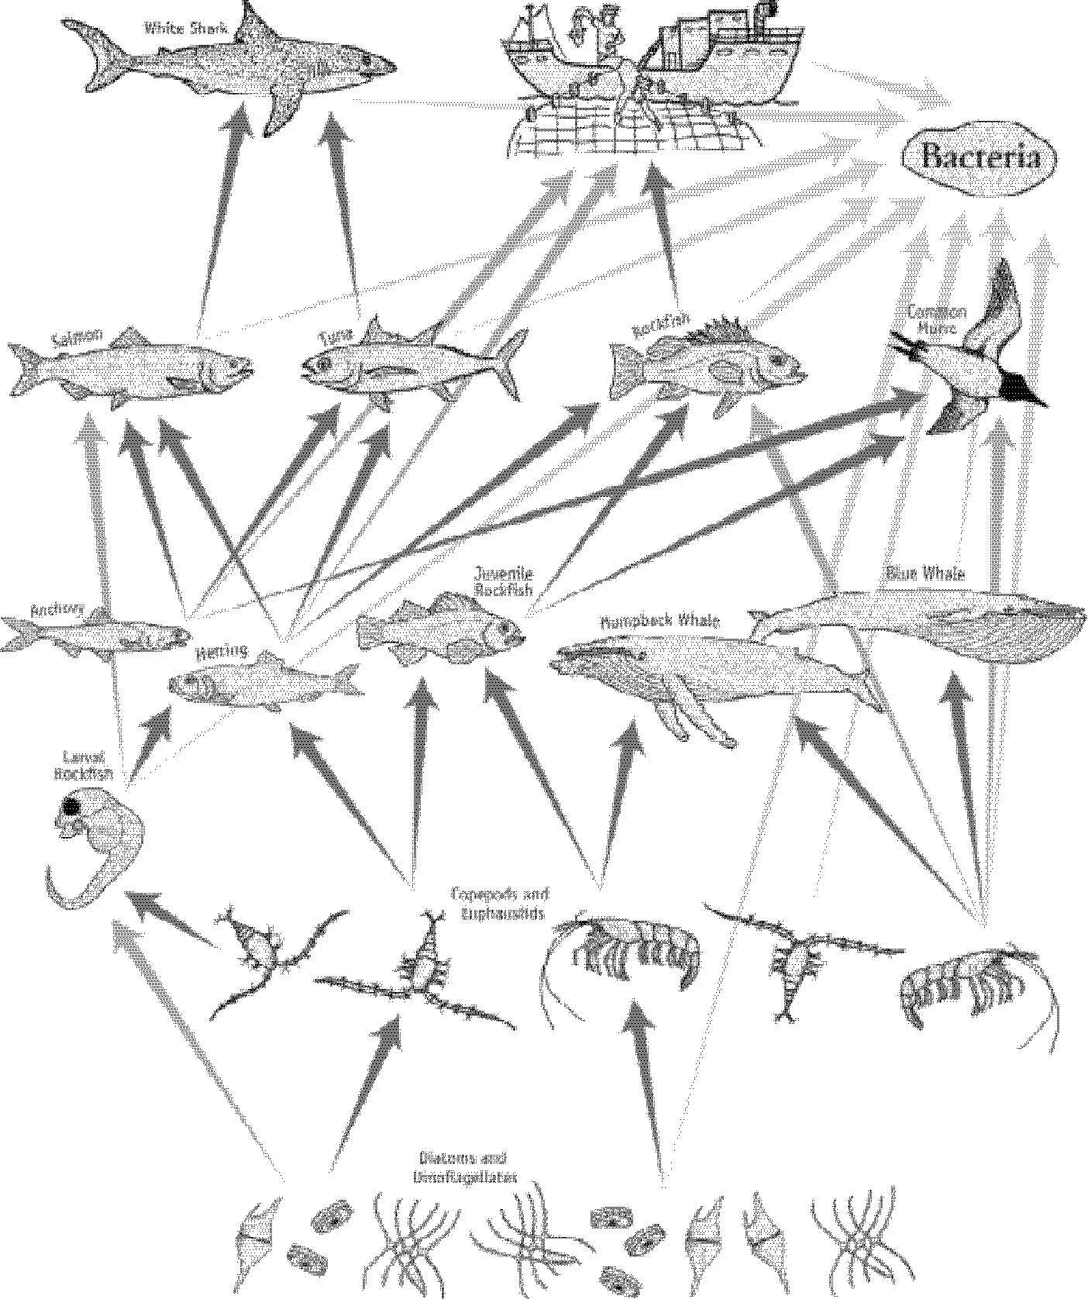

Feedback and Evaluation of the Coastal Ecosystem Curriculum

Name (optional) School/Organization
Mail Address
Email Address
Grade/Subject

Thanks for your interest in the Coastal Ecosystem Curriculum. We would like your assistance in improving this curriculum. Your responses may be incorporated into future printings of this and other educational material. Please mail this form to: Education Coordinator, Farallones Marine Sanctuary Association, P.O. Box 29386, San Francisco, CA 94129.

What were your goals and objectives for using these materials?

Which activities did you use? How well did they work (rate 1-6, 6 is very well)? Do you have any
suggestions for adaptations, extensions, or ways to improve the activities?

How useful was the background information?
not useful 1 2 3 4 5 6 very useful did not use

Did your students gain a better understanding about the coastal ecosystem? How did you evaluate your students?

Did you use the books and resources lists, website lists, or speaker lists? Were they useful? Please circle your response and comment.
books and resources lists: not useful 1 2 3 4 5 6 very useful did not use

website lists: not useful 1 2 3 4 5 6 very useful did not use

speaker list: not useful 1 2 3 4 5 6 very useful did not use

Do you plan to use this curriculum in the future? Why or why not?

How can we further assist you? What type of supplemental information would you like? (please in- clude your contact information)

Any other comments or suggestions

