To the west of the Golden Gate Bridge is a biologically rich ecosystem protected by the Gulf of the Farallones National Marine Sanctuary (NMS). The physical processes of the Gulf of the Farallones contribute to this ecosystem by upwelling nutrient- rich water to the surface during the spring and summer. Single-celled algae floating freely in the surface water use photosynthesis to capture energy which powers the entire web of life.
Upwelling regions are generally considered the most productive in the ocean due to the nutrient inputs from upwelling. The cold, nutrient-rich water is relatively sterile, but it provides the fertilizers that result in a very productive ecosystem. Diatoms are the dominant primary producers in the Gulf of the Farallones. Krill are the most important primary consumer here because so many species of fish, birds, and baleen whales eat them. Fish of all shapes and sizes are found in the next trophic levels. One well- known top predator in the Gulf is the white shark which feeds on seals.

Primary Producers
Floating in the water, single-celled algae, or phytoplankton, are mixed up and down through the lighted zone. They use photosynthesis to combine the energy of sunlight with carbon dioxide and other inorganic chemicals to produce high-energy carbohydrates and oxygen. Nutrients, the same chemicals used for agricultural use and home gardens, are required by phytoplankton. Nitrogen in the form nitrate (NO₃⁻¹) and phosphorous in the form phosphate (PO₄⁻³) are needed in the highest concentrations by phytoplankton. Phytoplankton absorb these nutrients into their cells. Phytoplankton absorb these nutrients into their cells and incorporate them into their molecules. In the Gulf of the Farallones during the upwelling season, nutrients are replenished from the deeper water. This nutrient supply is the driving force behind the rich biological community.

In the open water of the Gulf, krill and copepods are the abundant herbivores and spend their entire life as zooplankton, feeding on phytoplankton. Cope- pods make up over 70% of the zooplankton in the open ocean, yet in upwelling regions the larger-sized krill increase in abundance. Krill form daytime swarms at the surface during the upwelling season.

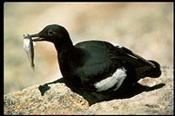
A Pigeon Guillemot is part of the food web in the Gulf of the Farallones.

Upper Trophic Levels
Not all carnivores are big, ferocious animals. Some are small, ferocious animals. Many single- celled protozoa eat bacteria. Chaetognaths, called arrow worms, are inch long lions of the planktonic world. These long, thin, transparent animals dart rapidly in the pursuit of other animals. Their mouth is fringed with spikes which grasp their prey. During the fall, jellies come into the Gulf and eat smaller zooplankton and phytoplankton.
Commercial fishermen know the upper trophic levels well. Northern anchovies and Pacific herring feed on plankton. Salmon feed on krill, squid, anchovies, and herring. Scavenging food on the sea floor, are the Dungeness crab. Blue, humpback, fin, and minke whales feed on the swarms of krill during the summer and fall. The Farallon Islands are home to the largest concentration of breeding seabirds in the contiguous United States. Seabirds, such as the Common Murre, feed on krill, juvenile rockfish, herring, anchovies, smelt, and squid.
Not all species feed at just one trophic level. As animals grow, they change prey and habitat. Fish begin feeding on small food particles as larvae and grow to eat larger zooplankton as juveniles. Rockfish are some of the most abundant bottom fish along the California coast and are harvested commercially. In their early life stage, they are plankton and eat smaller zooplankton. Adult rockfish settle to the bottom and eat crustaceans, squid, and small fish. Young white sharks feed on large fish until they grow to 10-12 feet long when they begin to eat seals. These changes make the description of the trophic structure within a specific ecosystem more complex.
The transfer of energy is very inefficient between trophic levels. About 90% of the energy is lost to metabolic costs and heat at each level. By feeding at lower trophic levels, there is more energy available. The loss of energy between trophic levels creates a decrease in the number of organisms in each level. Phytoplankton are the most abundant, the krill are less abundant, while the number of fish, whales, and birds that feed on krill is much less than the number of krill. The energy it takes to capture such small animals compared to the size of a whale could be considerable. Because krill are so abundant in this region, it is a perfect feeding habitat for baleen whales. The blue whale may be one thousand times larger than the food it eats. An adult may eat several thousand pounds of food per day, up to 100 pounds per swallow. Rather than teeth, the mouth of the largest whale is equipped with many overlapping fringed plates of a modified hair-like structure called baleen. It filters the inch long krill from the water with its baleen.

Bacteria
Last, but definitely not least, are the bacteria which work as decomposers and consumers. Many species breakdown waste and dead organic matter into inorganic compounds (carbon dioxide, nitrate, phosphate, etc.) to gain energy. As a byproduct, they recycle nutrients for the growth of phytoplankton. Other species of bacteria consume organic matter that phytoplankton release or exude from their cells or that zooplankton lose when they are eating. Copepods are known as “messy eaters,” because they spill lots of organic matter from the phytoplankton as they are eating. Bacteria play important roles in the food web and live in all habitats of the marine environment. The abundance, diversity, and other roles of bacteria are not well understood, although researchers are making new discoveries each year.
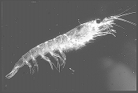
Krill form daytime swarms with up to 75,000 animals per cubic meter during the upwelling season in the Gulf of the Farallones.
Humans in the Gulf of the Farallones Food Web
In the Gulf of the Farallones, there are many important commercial species of fish and shellfish. The food web is a fragile system, and the removal or extinction of one level or even part of a population at one level can impact the entire food web. The importance of understanding the food web is clear when looking at the commercially harvested species. A potential fishery is the shortbelly rockfish, a small, schooling fish which eat krill and are eaten by salmon. If shortbellies are harvested, there may not be enough food for salmon.

Important commercial harvests of the Sanctuary
• Pacific herring (January-March)
• Salmon trolling (April-September)
• Rockfish (year-round)
• Bottom trawl fishery (sole, halibut, flounder) (year-round)
• Albacore tuna (August-October)
• Dungeness crab (November-June)
• Sea Urchins

Gulf of the Farallones National Marine Sanctuary Research
Knowing the abundance and distribution of biological resources along with the ocean conditions within the Sanctuary is critical management information. Since 1995, biologists affiliated with the Gulf of the Farallones NMS have investigated the abundance and distribution of marine organisms in the Sanctuary and described the oceanographic environment.
At 15 sampling stations, plankton nets and oceanographic instruments are used to sample the zooplankton and ocean conditions. Oceanographic conditions measured from the surface to sea floor include temperature, salinity, chlorophyll, and currents. Seabird and marine mammal observations are conducted during daytime transects between sampling stations.
Sanctuary managers hope to understand what is affecting the distribution and abundance of krill and how that is tied to the presence of higher level predators such as marine mammals, fish, and seabirds.

Glossary of Terms
Term | Definition
Algae (singular-alga) | photosynthetic, aquatic or marine organisms that resemble plants but have no seeds or roots, ranging from one-celled diatoms to multicellular seaweeds.
Baleen | horny material that hangs in plates with a fringed edge, from the roof of the mouth of Mysticeti or baleen whales. Used to filter or strain zooplankton and small fish.
Benthic | associated with the sea floor or pertaining to organisms living in or on the sea floor.
Bloom | high concentration of phytoplankton, formed during times of high reproduction.
Community | a group of living organisms in a given area that interact with each other; the living component of an ecosystem.
Consumer | organism that feeds on plants or phytoplankton (primary consumers) or other organisms (secondary or tertiary consumers).
Decomposer | heterotrophic organism, breaks down nonliving organic matter for energy and releases nutrients.
Diatoms | microscopic, single-celled phytoplankton which have silica (glass-like) valves and are abundant in upwelling waters.
Dinoflagellates | microscopic, single-celled organisms. Both plant and animal traits. They have flagella which provide them some locomotion. Some species cause toxic red tides.
Ecosystem | a term used to describe the relationships between organisms and their environment.
Euphausiids | small, shrimp-like crustaceans (type of Arthropods) that feed on diatoms and are food for many large whales. Commonly called krill.
Filter feeder | an animal whose feeding strategy is to filter water for food. An example in the Gulf of the Farallones is a sand crab.
Food chain | sequence of organisms in which each is food for the next member in the sequence.
Food web | complex of interacting food chains, all feeding relationships in a community.
Herbivore | an organism whose diet consists largely or totally of algae or plant material, a primary consumer.
Invertebrate | an animal without a backbone or spinal column.
Krill | a common name of euphausiids that are shrimp-like crustaceans (a type of Arthropod). Food for birds, fish, and many baleen whales.
Larvae | immature pre-adult stages of an organism, which do not structurally resemble the adults. Often have different diets and habitats than the adults.
Nutrient | any organic or inorganic compound used in primary production. Required by algae and plants for normal growth. Nitrogen and phosphorous compounds are important examples.
Organic | matter that is produced by living organisms, a chemical compound with a backbone of carbon atoms.
Organism | a living entity; can be a plant, animal, protist, bacteria, or fungus.
Pelagic | associated with the open water habitat of the ocean, not associated with the sea floor.
Photosynthesis | the process by which plants and algae use the sun’s energy to produce food. Carbon dioxide, water, and energy from light are combined into carbohydrates and oxygen.
Phytoplankton | drifting algae that have no control over the direction they travel. They use photosynthesis to produce food and are called primary producers.
Plankton | drifting algae and animals that have no control over the direction they travel; they are at the mercy of the currents.
Population ecology | branch of biology that deals with the number of a particular species that are found in an area and how and why those numbers change (or remain fixed) over time. Important in management of fisheries.
Primary producer | organism that creates new organic matter from non-living chemicals, uses photosynthesis or chemosynthesis.
Trophic level | position of an organism in the food chain or food web.
Upwelling | a process that occurs when strong winds blow surface water away from land, and deeper water comes up to the surface to replace it. This creates a highly productive biological community when the deeper water is nutrient rich.
Zooplankton | animals that float in the water and are at the mercy of the currents. Most are small crustaceans (1 mm-10 cm), although some are large jellyfish.

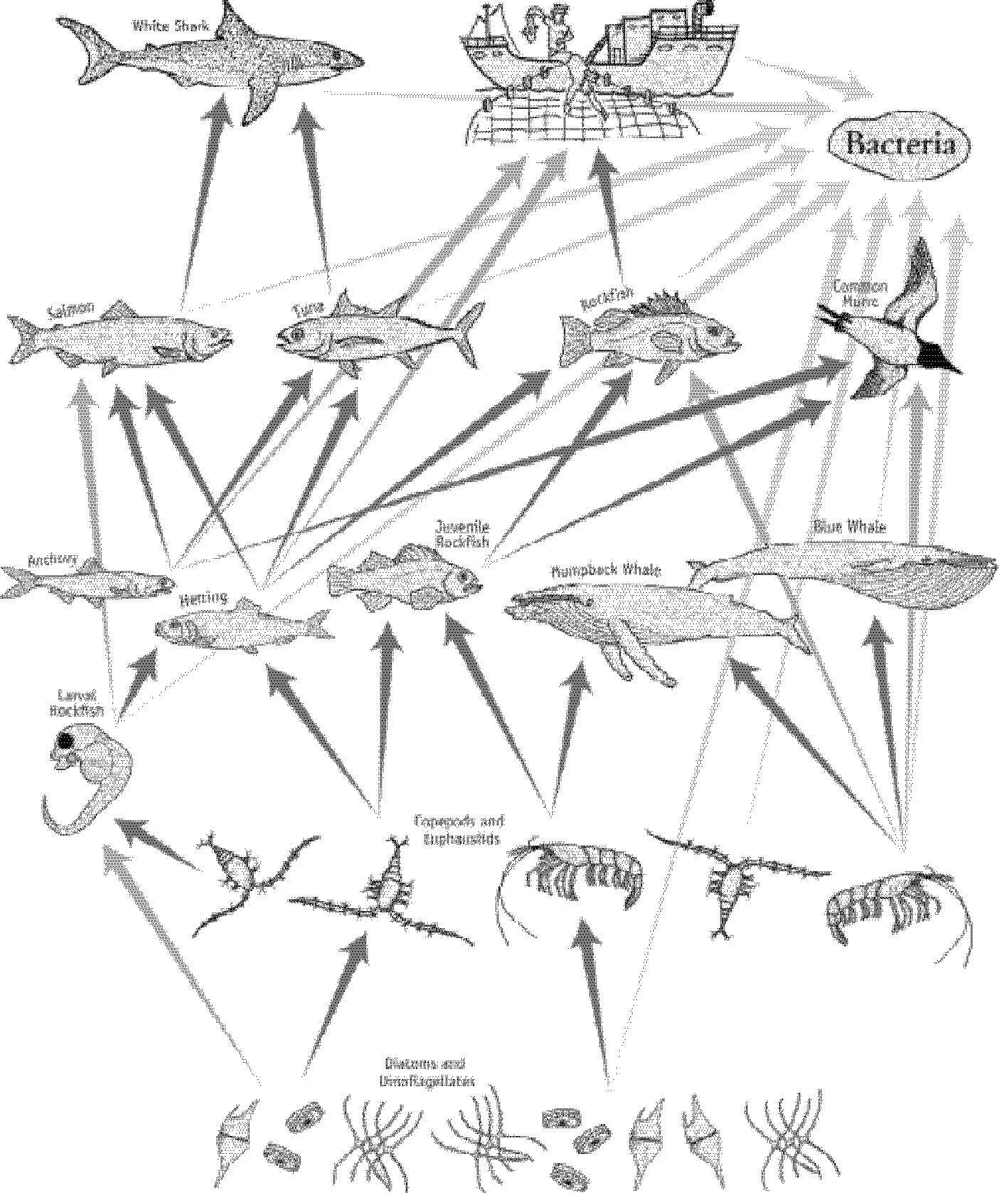
Food Web of the Gulf of Farallones

