Geometric Analysis of Muscle Function
How much force does your triceps lever system generate?

Step 1: Calculate triceps cross-sectional area (CSA_{t})

$${CSA}_{t}=\frac{Triceps Volume}{Triceps Muscle Fiber Length}$$

The muscles of the upper arm can be modeled as truncated cones joined together. Using your value of C, calculate the radius of the triceps at its widest point. Call this radius R_{t}.

Your Calculation | Sample Calculation
C = π D_{arm} | C = π D_{arm}
 | 12.25 = π D_{arm}
 | D_{arm} = 12.25 ÷ π
 | D_{arm} = 3.9 in
D_{t} = D_{arm} ÷ 2
= 3.9 ÷ 2
= 1.95 in
R_{t} = D_{t} ÷ 2
= 1.95 ÷ 2
= 0.975 in
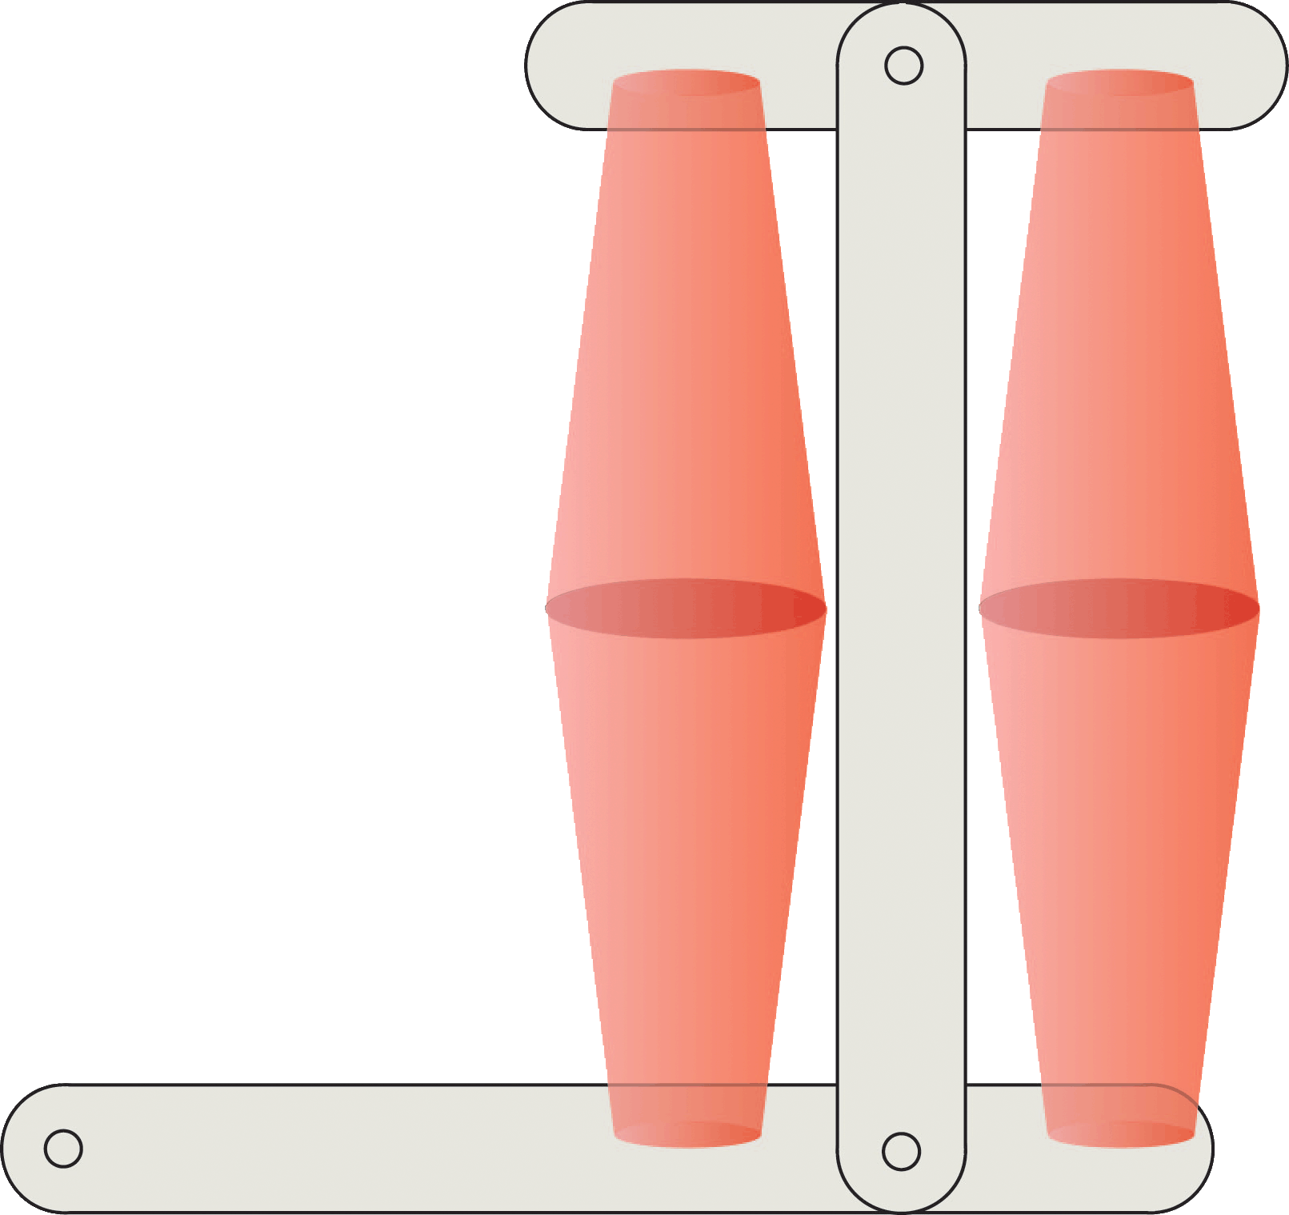

$$C$$
biceps
triceps

Calculate the triceps volume by first finding the volume of the lower truncated cone. Begin by finding L ÷ 2 and W ÷ 2.

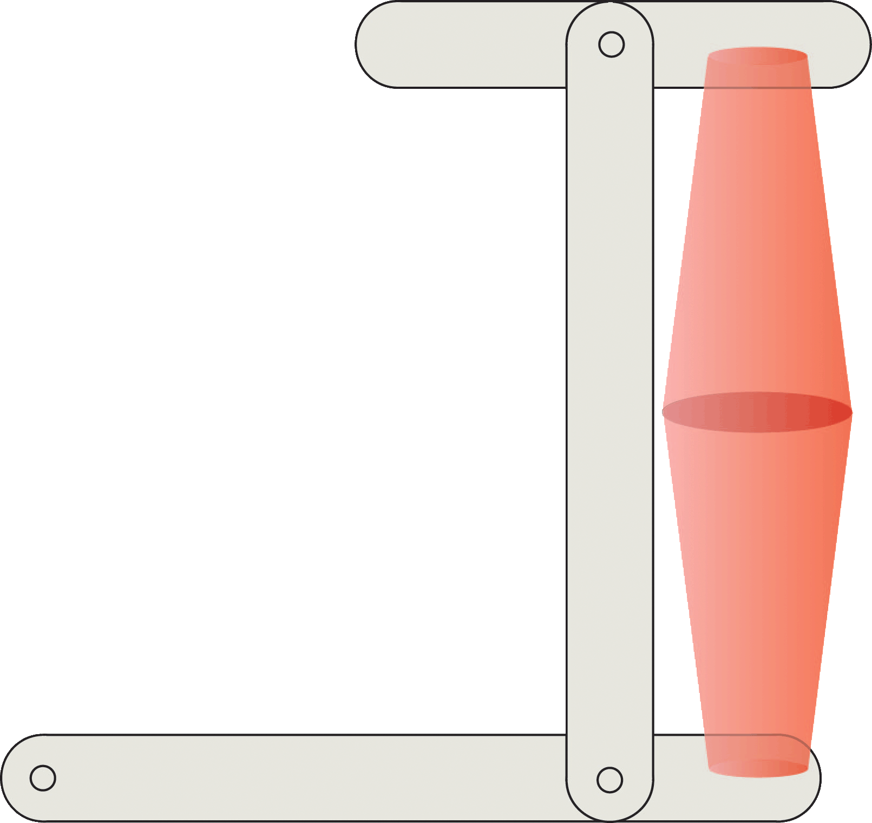
$$\frac{W}{2}$$

$$L$$
$$\frac{L}{2}$$
$$R_{t}$$

Your Calculation | Sample Calculation
L ÷ 2 = 14 ÷ 2
= 7 in
W ÷ 2 = 1 ÷ 2
= 0.5 in

Extend the truncated cone to a full cone and find its height using similar triangles.
$$\frac{H}{R_{t}}=\frac{H-\frac{L}{2}}{\frac{W}{2}}$$
$$\frac{L}{2}$$
$$R_{t}$$
$$\frac{W}{2}$$
$$H-\frac{L}{2}$$
$$H$$

Your Calculation | Sample Calculation
 | $$\frac{H}{0.975}=\frac{H-7}{0.5}$$
 | 0.5 H = 0.975 ( H – 7)
 | 0.5 H = 0.975 H – 0.975 (7)
 | 0.5 H = 0.975 H – 6.825
 | 0.5 H – 0.975 H = - 6.825
 | - 0.475 H = - 6.825
 | H = - 6.825 ÷ - 0.475
 | H = 14.37 in

Find the volume of the truncated cone.
$$\frac{L}{2}$$
$$R_{t}$$
$$\frac{W}{2}$$
$$H-\frac{L}{2}$$
$$H$$

$$V=\frac{1}{3}π\left[\left({R_{t}}^{2}H\right)-\left({\left(\frac{W}{2}\right)}^{2}\left(H-\frac{L}{2}\right)\right)\right]$$

Your Calculation | Sample Calculation
 | $$V=\frac{1}{3}π\left[\left({0.975)}^{2}(14.37\right)-\left({\left(0.5\right)}^{2}\left(14.37-7\right)\right)\right]$$
 | $$V=\frac{1}{3}π\left[\left(13.66\right)-\left(1.84\right)\right]$$
 | $$V=\frac{1}{3}π(11.82)$$
 | V = 12.37 in³
Since there are two truncated cones representing the triceps,
Volume of the triceps = V_{t} = 2 x V.
Your Calculation | Sample Calculation
 | V = 12.37
 | V_{t} = 2 x 12.37
 | V_{t} = 24.74 in³

Calculate the triceps muscle fiber length (FL_{t}). The angle θ is 45º.
θ

FL_{t}
R_{t}
Your Calculation | Sample Calculation
 | $${FL}_{t}=\frac{R_{t}}{\sin{θ}}=R_{t}\sqrt{2}$$
 | $${FL}_{t}=\frac{0.975}{\sin{45⁰}}=0.975 \sqrt{2}$$
 | FL_{t} = 1.38 in

Step 1: Calculate triceps cross-sectional area (CSA_{t})
CSA_{t} = Triceps Volume ÷ Triceps Muscle Fiber Length

Your Calculation | Sample Calculation
CSA_{t} = V_{t} ÷ FL_{t}
= 24.74 ÷ 1.38
= 17.93 in²

Step 2: Calculate triceps muscle force (F_{t})
Specific tension (T_{s}) = 51 lb/in²
Triceps muscle fiber angle (θ) = 45°
F_{t} = CSA_{t} x T_{s} x cos θ

Your Calculation | Sample Calculation
F_{t} = CSA_{t} x T_{s} x cos 45º
= 17.93 x 51x 0.7071
= 646.6 lb

Step 3: Calculate triceps level system force (F_{tls})
F_{tls} = F_{t} x L_{i} ÷L_{o}

Your Calculation | Sample Calculation
F_{tls} = F_{t} x L_{i} ÷ L_{o}
= 646.6 x 1 ÷ 11
= 58.78 lb

$$F_{t}$$
$$F_{tls}$$
$$L_{i}$$
$$L_{o}$$

