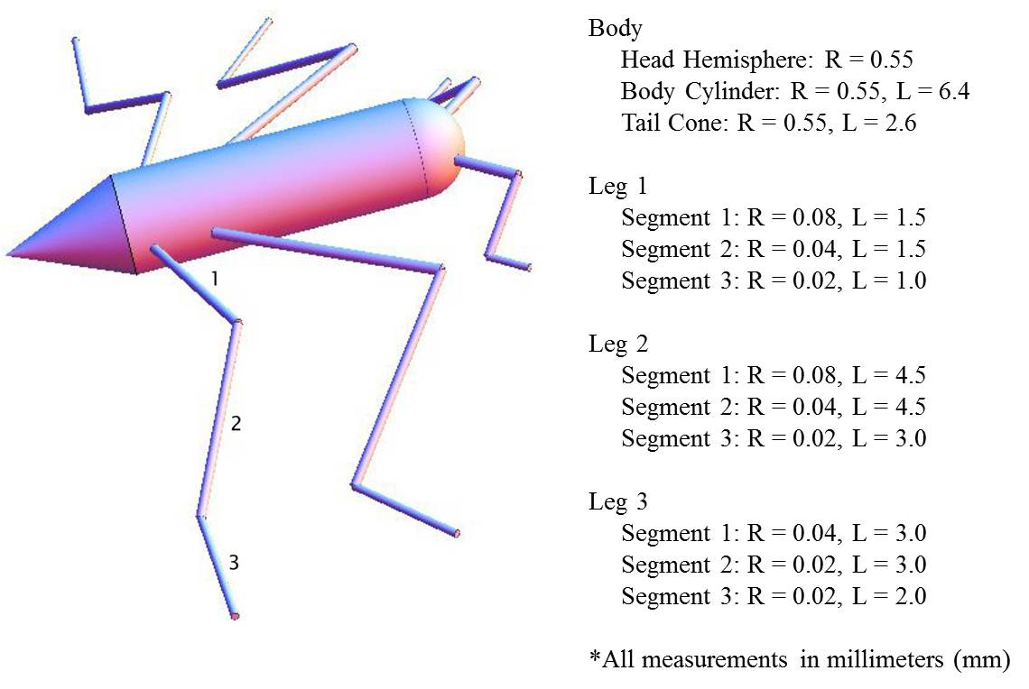

  - Find the Contact Perimeter (P) of the water strider and enter your answer in the appropriate space on the worksheet.

    - Given:

      - Only the tarsal segments (segment 3) of each leg are in contact with the water.

      - Contact Perimeter $P=2×2(L_{1}+L_{2}+L_{3})$

  - Find the body mass of the water strider by first computing the volume of the water strider and then using the density formula. Enter your answers in the appropriate spaces on the worksheet.

    - Given:

      - Dimensions of all body segments

      - Density of the water strider body = 0.0012 g/mm³

      - $Density =\frac{Mass}{Volume}$

  - Find the ratio of body weight to surface tension force for the water strider and enter your answer in the table below.

    - Given:
      - $M_{c}=\frac{body weight}{surface tension force}=\frac{mg}{P}$

      - $m=0.009132 grams$

      - $g=0.0098 mm/{ms}^{2}$

      - $=0.000067 N/mm$

      - $P=24 mm$

  - How big can a water strider get and still stay afloat? Use the worksheets with body segment dimensions multiplied by two, four, and eight to compute the ratio of body weight to surface tension force at these new dimensions and enter your answers in the table below.

    - Given:
    - $M_{c}=\frac{body weight}{surface tension force}<1=Floating$
    - $M_{c}=\frac{body weight}{surface tension force}>1=Sinking$

Dimension Scale | Formula | Calculation | $$M_{c}$$
Original | $$\frac{body weight}{surface tension force}=\frac{mg}{P}$$ | $$\frac{0.009132×0.0098}{0.000067×24}$$ | 0.056
X 2 | $$\frac{body weight}{surface tension force}=\frac{mg}{P}$$
X 4 | $$\frac{body weight}{surface tension force}=\frac{mg}{P}$$
X 8 | $$\frac{body weight}{surface tension force}=\frac{mg}{P}$$

