Name:________________________________________________ Date:______________________ Period________

Understanding Abiogenesis

In 1920 Oparin and Haldane proposed a reducing atmosphere hypothesis for early earth. In 1953 Miller and Urey devise a way to test this hypothesis by recreating the proposed reducing atmosphere as well as replicating the proposed lightning energy source. The products of this experiment were biomolecules essential to life or important precursors to those molecules. This experiment provided support for Abiogenesis or life arising from nonlife.

Biomolecules (or Precursors) Produced by Abiogenesis Experiments

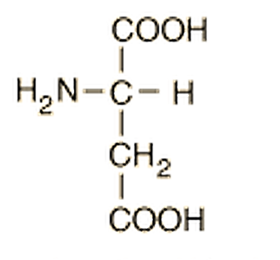
C₄H₇NO₄
Aspartic acid
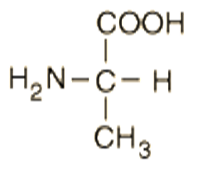
C₃H₇NO₂
Alanine
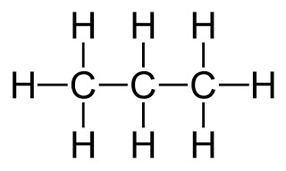
Propane
C₃H₈

Glycolaldehyde
C₂H₆O₂

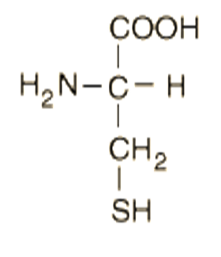
C₃H₇NO₂S
Cysteine
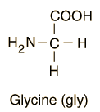
C₂H₅NO₂
Glycine
Adenine
C₅H₅N₅
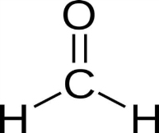
Formaldehyde
CH₂O

C₅H₁₁NO₂S
Methionine

Fatty Acid
CH₃(CH₂)₁₀COOH

1) Examine the molecules produced in the Abiogenesis experiments. Categorize their importance to life into the chart below based on the structure of each. Be sure to draw and label the molecule in each appropriate column.
*Hints have been inserted into each column to help you.

Carbohydrates  (C_{x}H₂O_{x}) | Lipids  (Hydrocarbons: C backbone bonded to many H’s) | Proteins  (Amino Acids: Central Carbon bonded to H, NH2, COOH and variable group) | Nucleic Acids  (Nitrogenous bases: purines- double C & N ring, Pyrimidines- single C & N ring)
Glycolaldehyde  C₂H₆O₂  Formaldehyde  CH₂O | Fatty Acid  CH₃(CH₂)₁₀COOH  Propane  C₃H₈ | 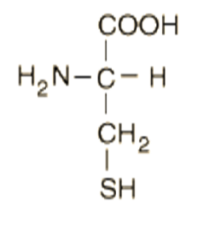  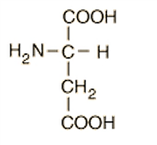  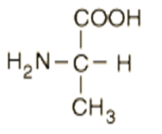  C₅H₁₁NO₂S  Methionine  C₃H₇NO₂S  Cysteine  C₂H₅NO₂  Glycine  C₄H₇NO₄  Aspartic acid  C₃H₇NO₂  Alanine | Adenine  C₅H₅N₅

2) Why were these molecules so important to the formation of life?
These molecules form the building blocks of life- they make up the four categories of biomolecules (or percursors to those) necessary to building cells.

Carbohydrates- energy and structure (formaldehyde and glycolaldehyde are precursors to sugars)

Lipids- cell membranes, energy (propane is a basic hydrocarbon which is a precursor to lipids, fatty acids are necessary components of phospholipids which make up cell membranes and triglycerides which are important lipids involved in energy storage)

Proteins- structure, catalysis, transport, etc (Methionine is an especially important amino acid as it is the initiation amino acid during protein synthesis for eukaryotes as well as archeans- the extremophiles that were among the first living organisms.

Nucleic Acids (DNA/RNA)- cell reproduction, protein synthesis/ genetic expression (adenine is a nitrogenous base involved in the structure and genetic coding of DNA; it is also a vital component of the energy molecule ATP)

The inorganic molecules present in the Miller-Urey laboratory atmosphere (H₂O, H₂, CH_{4,} NH₃), are shown below.

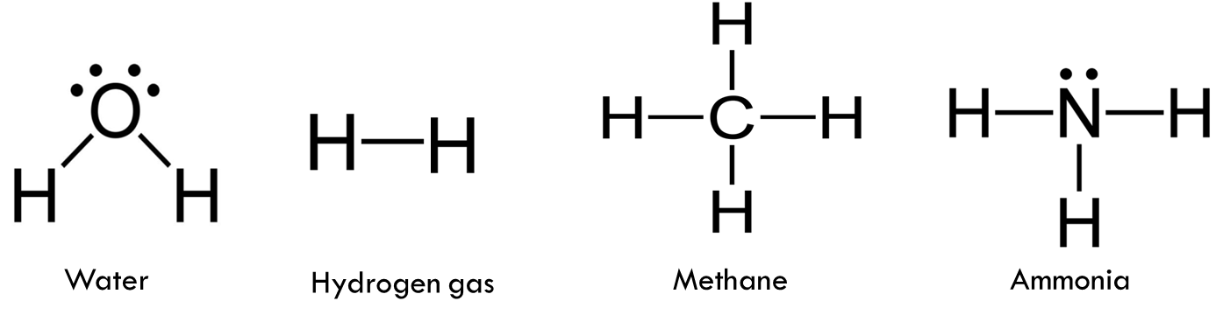

3) Examine the chart “Biomolecules Produced by Abiogenesis Experiments” and determine for each molecule listed which molecules in Miller’s laboratory atmosphere would have come together to create these biomolecules.
***Shown below are some possible student answers.***
Biomolecule Produced | Possible Inorganic Molecules Needed to Build Biomolecule
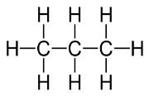  Propane  C₃H₈ | Methane  H-H Hydrogen gas
Glycolaldehyde  C₂H₆O₂ | 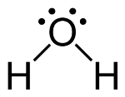  Methane  Water
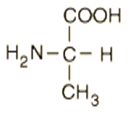  C₃H₇NO₂  Alanine | 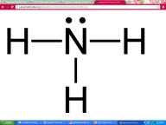  Methane  Water  Ammonia
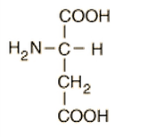  C₄H₇NO₄  Aspartic acid | Methane  Water
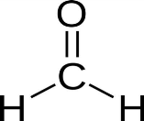  Formaldehyde  CH₂O | Methane  Water
Adenine  C₅H₅N₅  C₂H₅NO₂  Glycine | Ammonia  Methane  Water
Ammonia
Methane
Water
Fatty Acid  CH₃(CH₂)₁₀COOH | Methane  Water
Some evidence suggests that Earth's original atmosphere may have differed from the one proposed by the Urey Miller Experiment. There is abundant evidence of major volcanic eruptions 4 billion years ago, which would have released carbon dioxide(CO₂), nitrogen(N), hydrogen sulfide (H₂S), and sulfur dioxide (SO₂) into the atmosphere. Experiments using these gases in addition to the ones in the original Miller–Urey experiment have produced more diverse molecules.

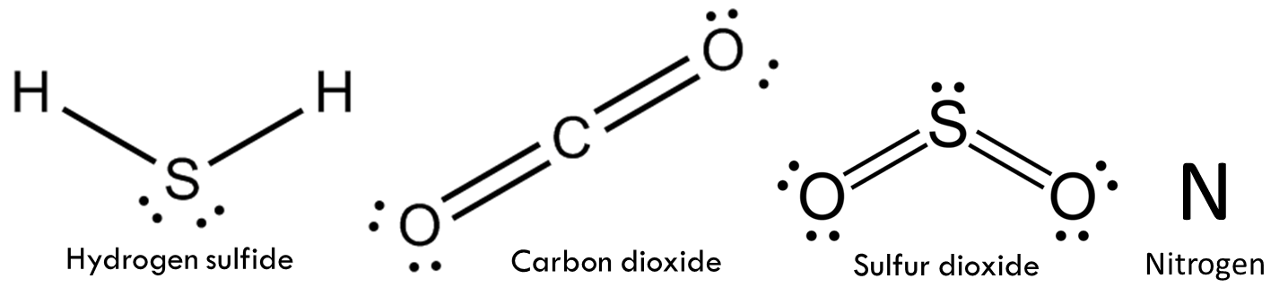

4) Examine the molecules remaining on the “Biomolecules Produced by Abiogenesis Experiments” chart and determine if the molecules available in this revised atmosphere could have played a part in their formation.
Complete the chart for these molecules as before.
***Shown below are some possible student answers.***
Biomolecule Produced | Possible Inorganic Molecules Needed to Build Biomolecule
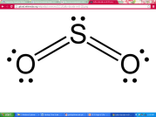  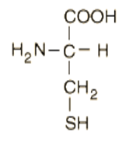  Sulfur dioxide  C₃H₇NO₂S  Cysteine | Ammonia  Methane
C₅H₁₁NO₂S  Methionine | Methane  Ammonia  Sulfur dioxide

5) The following are statements about the nature of science. For each evaluate how the Miller-Urey Experiment as well as later experiments discussed supports these statements.

A) Scientific knowledge is based on empirical evidence, and is appropriate for understanding the natural world, but it provides only a limited understanding of the supernatural, aesthetic, or other ways of knowing, such as art, philosophy, or religion.
Science is limited to investigating the natural world and therefore unable to investigate supernatural phenomena or religious dogma which are neither tangible nor repeatable in nature. The products of science (probable explanations for natural phenomena) are always based on observations carefully analyzed and tested. The

Abiogenesis experiments investigate the natural phenomena of life through observations and repeatable experimentation. Oparin and Haldane began with observation of the nature of chemistry and life and hypothesis, Miller and Urey were able to test that hypothesis in a lab many times, and later scientists were able to further these experiments as new data/observations became available.

B) Scientific knowledge is durable and robust, but open to change.
The initial data favored water, hydrogen gas, methane and ammonia being present in an early reducing atmosphere and this is the scenario that Miller and Urey tested. More recent data suggests volcanic activity played a major role in contributing sulfurous molecules into the atmosphere. Scientists have adapted this information into more recent tests and experiments using these gases in addition to the ones in the original Miller–Urey experiment have produced more diverse molecules.

