INFECTION
Graphing the Results of “Bacteria vs. Antibodies: Who Will Win?”
Converting Immunology “Data” to Graphical Form

Goal: To work on skills in scientific graphing and to understand the use of a logarithm based scale to compare antibody production levels relative to bacterial doubling and bacterial loads.
Introduction: When your body is attacked by an infectious invader for the first time, it launches what is called a Primary Immune Response, in which your immune system works to identify key features of the invader for use in developing an antibody. Antibodies recognize and bind to the antigen (surface of the invader), which signals to macrophage cells to come consume the invader, neutralizing its danger. This process takes time for the immune system to figure out, and as a result, it takes 9-14 days on average for the body to begin to produce antibodies to use to fight the invader (Figure 1). After initial infection is over, the immune system produces B Memory cells, cells able to produce the specific antibody to the original invader. If you get another of that same infectious agent in your body, then the immune system can more quickly act to fight it through the process of the Secondary Immune Response. This module is to help you understand the process of how quickly bacterial populations grow though doubling, and how the primary and secondary immune responses produce antibodies that can be used to reduce the bacteria, thus causing a change in the bacterial load.

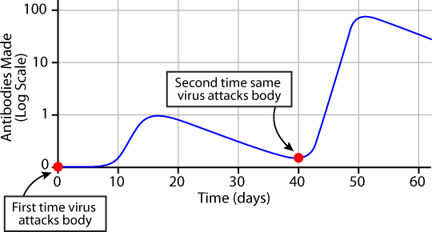 | Figure 1: Primary versus secondary antibody response. Initially when invader attacks, adaptive immune response takes time, but upon a repeat attack, the immune system can quickly respond to the invader, through B Memory Cells, produced during the first attack. http://askabiologist.asu.edu/sites/default/files/resources/activities/body_depot/viral_attack/graph1.gif

Instructions: Once you complete the “Bacteria vs. Antibodies: Who Will Win?” game, take your scorecards, and look at your last three columns for both your Primary and Secondary Response games. This is where you have calculated the bacterial doubling (Column 7), antibody amount (Column 8), and bacterial load (Column 9). In this exercise, you will graph the data in these three columns in two ways, 1) using a typical graph with your X axis the Roll# from your scorecard, representing time, and your Y axis your measurement of both number of bacteria and number of antibodies. The Y-axis has an even count of bacteria and antibodies, with values ranging from 0 to 12000000. First, using different colored markers to plot the results of your Primary Immune Response, plot the Roll # (Column 1) against Bacterial Doubling (Column 7), Roll # (Column 1) against Antibody Response (Column 8), and Roll # (Column 1) and Bacterial Load (Column 9) on the blank Figure 2. Second, do the same thing on the same figure for the data from your Secondary Immune Response, for a total of 6 lines on the figure. As you plot the data, for BOTH your Antibody Response (8) and your Bacterial Load (9) columns, enter a ‘0’ value for each roll # during which you were working on completing a step in the primary immune response. Once you get to step H in your immune system response you should have numbers to plot from both of these columns (8 & 9).

As you plotted your data in Figure 2, did you have problems being able to include all the data you were given? Because of the dramatically large numbers you get from doubling values and quadrupling them, trying to graph numbers that are very different from each other is difficult, because the axis includes so many values (0 to 12000000 in this case). This results in graphs where small values are difficult to detect because they look so similar to zero.

For the second graph, you will be plotting the same data as above. First, using different colored markers to plot the results of your Primary Immune Response, plot the Roll # (Column 1) against Bacterial Doubling (Column 7), Roll # (Column 1) against Antibody Response (Column 8), and Roll # (Column 1) and Bacterial Load (Column 9) on the blank Figure 2. Second, do the same thing on the same figure for the data from your Secondary Immune Response, for a total of 6 lines on the figure. However, this Y axis is different than the first one because it is on a LOG₁₀ scale. This type of scale, where instead of even breaks between values you have breaks that are 10 times larger than the previous one, allows you to deal with numbers that get large very fast. A log scale turns exponential functions (graphs that have a ‘J’ shaped curve) into graphs that are nice straight lines, by reducing the differences between very small and very large numbers. Go look at the scale on Figure 3 for the Y axis. Notice that at each major axis tick mark, the next higher interval is ten times that of the next one down. Also notice the space between the tick marks and that the minor tick marks are not spaced evenly either. This is a type of scale that is used to measure lots of things, like the Richter Scale for measuring earthquake magnitude and the pH scale for measuring the acidity of your orange juice.

Being careful of the scale used on the Y-axis, plot the data listed in the above paragraph, for a total of 6 lines on Figure 3. How does this graph look different from Figure 2? Is it easier to read? Were you able to include more information on it? What do you think caused the difference between the two graphs?

How did your primary and secondary response graphs look different from one another? Why do you think there was such a low level of bacteria seen in your secondary response compared to your primary response?

To see how these numbers of antibodies and bacteria can really grow, look at the table on the last page of this handout, and compare these numbers to the graphs you drew.

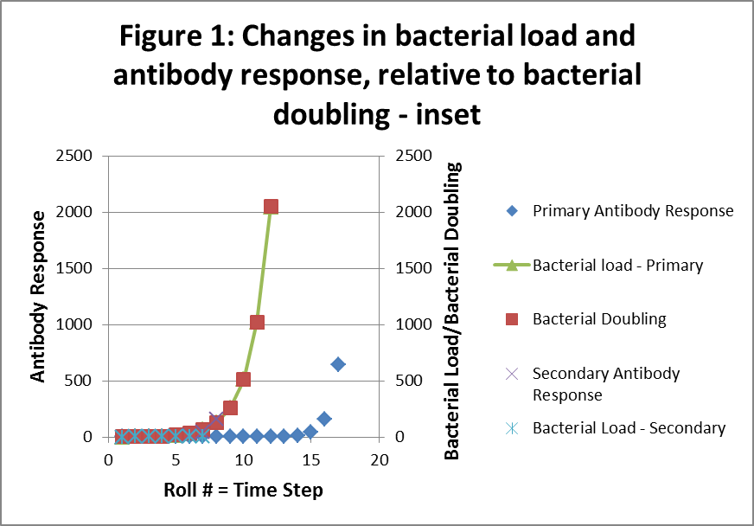

Roll # = Time Step | Primary Antibody Response | Bacterial Doubling | Bacterial load - Primary | Secondary Antibody Response | Bacterial Load - Secondary
1 | 0 | 1 | 1 | 0 | 1
2 | 0 | 2 | 2 | 0 | 2
3 | 0 | 4 | 4 | 0 | 4
4 | 0 | 8 | 8 | 1 | 7
5 | 0 | 16 | 16 | 10 | 6
6 | 0 | 32 | 32 | 40 | 1
7 | 0 | 64 | 64 | 160 | -96
8 | 0 | 128 | 128 | 640 | -512
9 | 0 | 256 | 256 | 2560 | -2304
10 | 0 | 512 | 512 | 10240 | -9728
11 | 0 | 1024 | 1024 | 40960 | -39936
12 | 0 | 2048 | 2048 | 163840 | -161792
13 | 1 | 4096 | 4095 | 655360 | -651264
14 | 10 | 8192 | 8182 | 2621440 | -2613248
15 | 40 | 16384 | 16344 | 10485760 | -10469376
16 | 160 | 32768 | 32608 | 41943040 | -41910272
17 | 640 | 65536 | 64896 | 167772160 | -167706624
18 | 2560 | 131072 | 128512 | 671088640 | -670957568
19 | 10240 | 262144 | 251904 | 2684354560 | -2684092416
20 | 40960 | 524288 | 483328 | 10737418240 | -1.0737E+10
21 | 163840 | 1048576 | 884736 | 42949672960 | -4.2949E+10
22 | 655360 | 2097152 | 1441792 | 1.71799E+11 | -1.718E+11
23 | 2621440 | 4194304 | 1572864 | 6.87195E+11 | -6.8719E+11
24 | 10485760 | 8388608 | -2097152
25 | 41943040 | 16777216 | -25165824
26 | 167772160 | 33554432 | -134217728
27 | 671088640 | 67108864 | -603979776
28 | 2684354560 | 134217728 | -2550136832
29 | 10737418240 | 268435456 | -10468982784
30 | 42949672960 | 536870912 | -42412802048

