Name:________________________________________________ Date:______________________ Period________

Understanding Abiogenesis – moving from polymers to protocells - Key

Introduction: If you Google experiments on the origin of life on earth, you will see that it is a very active area of research. Much of the area of research is organized under terms such as “chemical evolution” and “chemical origin of life” and “abiogenesis”, focusing on the chemistry of the early earth environment and its role in both the creation of early molecules that were likely components of early proto-life structures, typically called protocells or coacervates.
Today we are going to create models of some of these early cells, to visualize what happens in simple systems with proto-membranes – early structures that allowed ancient cellular life to separate themselves from the outside world.
Given what you know about the importance of membranes in modern biological systems, why do you think that it was critical for these earliest organisms to have a membrane?
Membrane critical for organisms to separate self from non-self.

Brainstorm with your team to identify what you consider the essential components that a protocell would have to have to consider it alive, and record your list here:
Some possible student answers: nutrition, movement, excretion, respiration, sensitivity/regulation, growth, reproduction
Best answer: membrane separating self from non self, metabolism, heredity/heritable information

1. Creating membranes from phospholipids (procedure modified from Flammer, 1999; for more ideas and details of the experiment, see http://www.indiana.edu/~ensiweb/lessons/coacerv.html) – For this demonstration/experiment, students are taking a phospholipid (phosphatidyl choline source; Lecithin, available at GNC in large quantities or the drug store), mixing it with water, and then over time watching as the phospholipids assemble into micelles. As those small micelles begin to come into contact with each other over time, they will coalesce, creating larger structures with the polar head groups exposed to the water, and the nonpolar tails buried in the center of the molecules in a single layer of phospholipids. The food coloring is used to help visualize these structures, and as a result, darker colors are better than lighter ones. The micelles will form in the lecithin solution side, and at the interface as they drift over to the food coloring side you can see them against the dark field (because there is no food coloring inside the micelle structure).
Based on the description above, how do these proto-membranes differ from modern membranes seen in living cells?
Modern cells have a double membrane (a membrane bi-layer – look for a picture in your text – see figure 1, A below) with two layers, and these only have a single phospholipid layer.

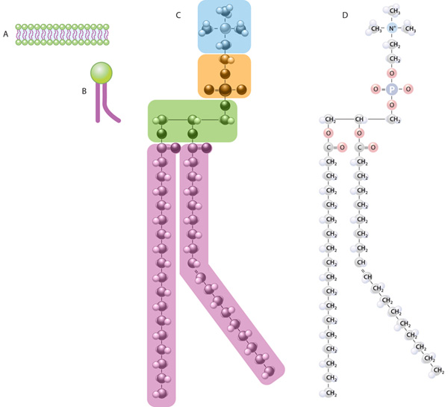
Figure 1: Chemical structure of phosphatidylcholine, with image from http://www.nature.com/scitable/topicpage/cell-membranes-14052567.
Look at the chemical structure of this phospholipid. Use your knowledge of what atoms form polar covalent bonds and what atoms form non-polar covalent bonds to predict which region of the molecule will interact with water, and which region will avoid water. Label these two regions on molecule D as polar or non-polar, and water-loving vs. water avoiding.
Answer: phosphate head group and choline is the top of the molecule and is polar and water-loving, and the two hydrocarbon chains at the bottom of the molecule are non-polar and water-avoiding.
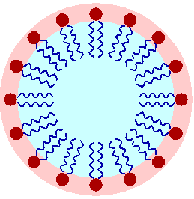
Using the model phospholipid in section B of Figure 1, draw the shape of the structure that you expect the material to form when you add it to pure water.

Answer:

Materials needed for procedure:
Slides and coverslips
Food coloring (darker colors work better)
Transfer pipettes or eyedroppers
Microscopes with variable light level and magnification up to 400X
Lecithin solution (1% solution; make with DI water if possible) – to make the solution, use 1 gram of Soy Lecithin Granules (GNC brand) dissolved in 100 ml of DI water. Student groups only need a few milliliters each to do the demonstration, and the solution keeps in the refrigerator for a few days, so this amount should be sufficient for a class with 15 groups of 2 students each.
Procedure:
- Place 1 drop of lecithin solution in the center of a clean slide
- Separated from the original drop by a couple of millimeters, place a drop of food coloring, diluted with just a small amount of water (diluted by half)
- Drop a clean cover slip over the top of the two drops so that you can see a line down the middle between the two.
- Place slide setup on microscope stand, and visualize at low magnification in the area along the line between the two solutions. Find the micelles.
- Focus under high magnification on one of these structures (preferably in a region with multiple structures of this type close to each other) and observe every 5 minutes during the next half hour. Record your observations each time.
Microscope recommendations – for this demo, it is good to leave it sit over time to watch the larger structures form, so setting up a class demo while they work on the other procedure would be a good idea. Use the lowest magnification to locate the small micelles at the interface between the lecithin solution and the food coloring. Distinguish them from air bubbles using size (because the air bubbles are larger) and the distinct edges (air bubbles have very clearly demarcated edges). Focus on one of the micelle structures at low magnification and then increase the magnification to 40X. Light level helps get them into focus, with a higher light level needed the darker the food coloring you use.
Record your observations here, noting how the structures moved and behaved in each 5 minute interval. Also draw the structures you see, including a note regarding the magnification level you used to view the demonstration.
Drawing:
Time (min) | Observation
0-5
10
15
20
25
30

2. Creating protocells (coacervates) – This experiment/demonstration uses a protein (gelatin) and carbohydrate (gum arabic) to create structures that look like amoeba, with outer membrane-like structures, inner vacuoles, and amoeba-like movement. Use the attached Coacervate Pre-lab Worksheet to work through the exercise and answer questions (developed by L. Flammer 1999).
Materials needed:
Slides and coverslips
Food coloring (darker colors work better)
Transfer pipettes or eyedroppers
Microscopes with variable light level and magnification up to 400X
1% gum arabic solution (can be purchased in bulk from Amazon, high end cooking stores, and art supply houses)
1% gelatin solution (Knox brand purchased from the store works well)
  - M HCl solution
pH paper to record the pH of the solution

Procedure:
- Mix 1% solutions of gelatin and gum arabic together in a 5:3 ratio (5 ml of 1% gelatin mixed in a test tube with 3 ml 1% gum arabic)
- Transfer 2-3 ml of solution to a new test tube
- Add 1 drop of acid to the solution, which will make the solution go from clear to cloudy. Mix solution, and if it stays cloudy you are ready to go, but if it clears up, add one more drop of acid to the mix
- Place a drop of this final solution on a clean slide
- Separated from the original drop by a couple of millimeters, place a drop of food coloring
- Drop a clean cover slip over the top of the two drops so that you can see a line down the middle between the two.
- Place slide setup on microscope stand, and visualize at low magnification in the area along the line between the two solutions. Find the micelles.
- Focus under high magnification on one of these structures (preferably in a region with multiple structures of this type close to each other) and observe every 5 minutes during the remaining class period. Record your observations each time.
Microscope recommendations – for this demo, it is good to leave it sit over time to watch the larger structures form, so setting up a class demo while they work on the other procedure would be a good idea. Use the lowest magnification to locate the small structures at the interface between the gelatin/gum arabic solution and the food coloring. Distinguish them from air bubbles using size (because the air bubbles are larger) and the distinct edges (air bubbles have very clearly demarcated edges). Focus on one of the amoeba-like structures at low magnification and then increase the magnification to 40X. Light level helps get them into focus, with a higher light level needed the darker the food coloring you use.
Record your observations here –

3. Chemical movement: protocells that move like ciliates – This demonstration is more advanced than the previous two, with the creation of a pH driven chemical motor that moves an acid protocell made from an oil droplet around in an alkaline water environment. Because the materials are toxic, we decided to use a YouTube video to view the experiment. The work in the video was authored by Dr. Martin Hanczyc, working in the field of chemical evolution. Here is the link to Dr. Hanczyc’s research – a talk he gave for TED (protocells shown at minute 5.55 of video, but the entire lecture is interesting to watch, http://www.ted.com/talks/martin_hanczyc_the_line_between_life_and_not_life.html), as well as a link to the behavior of multiple protocells in solution Protocell Circus by Dr. Rachel Armstrong http://www.youtube.com/watch?v=Fv0accakZ1k.
What are the characteristics of the protocells shown here that make them seem alive?
Separation of themselves from the environment, simple metabolism, ability to move, behave, etc.

What DON’T these protocells have compared to the simplest form of living cells, the anerobic bacteria?
Heritable information - they can replicate, but not pass on information from generation to generation

Resources to help your understanding:
Dr. Martin Hanczyc is a researcher working on the development of protocells with chemical movement properties, with his research highlighted in the Journal Nature as well as other high profile formats (like the series “Into the Wormhole”). Sites where you can view video clips of his work or scientific papers are below:
- http://www.ted.com/talks/martin_hanczyc_the_line_between_life_and_not_life.html
- http://www.youtube.com/watch?v=Wg-A8G954-U
- Oil droplets mimic early life http://www.nature.com/news/2011/110223/full/news.2011.118.html
- Structure and the synthesis of design - http://onlinelibrary.wiley.com.lp.hscl.ufl.edu/doi/10.1002/ad.1209/pdf (available on web site)

Many researchers are currently working on topics related to abiogenesis and chemical evolution, the field of science investigating how life may have begun on planet earth. Resources to read that might be helpful in developing materials for this area are below.
- Schrum, J et al. 2010. The origins of cellular life. http://cshperspectives.cshlp.org/content/2/9/a002212.full
- Experimental models of primitive cellular compartments: Encapsulation, Growth, and Division http://www.sciencemag.org/content/302/5645/618.full
- Exploding vesicles. http://www.jsystchem.com/content/2/1/4
- Membrane transport in primitive cells - http://cshperspectives.cshlp.org/content/2/8/a002188.full.pdf+html
- Rasmussen, et al. Transitions from living to non-living matter - http://www.jstor.org.lp.hscl.ufl.edu/stable/pdfplus/3836121.pdf?acceptTC=true (available on web site)
Research in this area has focused strongly on the environmental context of the origin of life, investigating the role of the pH of the environment (acidity vs. alkalinity), amount of oxygen in the atmosphere, temperature (heat vs. ice), etc. Research on these components is listed below.
- The importance of being alkaline. Science. http://www.sciencemag.org/content/302/5645/580.summary
- http://en.wikipedia.org/wiki/Geological_history_of_oxygen
- Geological changes on the earth over time - http://www.docbrown.info/page21/GeoChangesANS01.htm
- RNA world hypothesis - http://en.wikipedia.org/wiki/RNA_world_hypothesis
- Ice plays a role in early life
  - Was ice the original “cell” in early earth? - http://www.nasw.org/users/mslong/2010/2010_09/Ice.htm
  - Ice as a protocellular medium for RNA replication - http://www.nature.com/ncomms/journal/v1/n6/full/ncomms1076.html
  - Cold start of life - http://olexandrisayev.com/2010/cold-start-of-life-ice-as-a-protocellular-medium-for-rna-replication/
  - Was ice the original “cell” in early earth? - http://www.nasw.org/users/mslong/2010/2010_09/Ice.htm
- Abiogenesis – http://en.wikipedia.org/wiki/Abiogenesis

Chemicals/systems used to study the origin of early life
- Nitrobenzene http://ijopp.org/oct_dec_2012/88-90.pdf
- Phospholipids and the formation of cell membranes - http://www.nature.com/scitable/topicpage/cell-membranes-14052567
- Origin of life: Coacervate formation - http://www.indiana.edu/~ensiweb/lessons/coacerv.html

Teaching methods for “origin of life” concepts
- Interactive notes, Teaching for Excellence site - http://www.teachingforexcellence.com/wp-content/uploads/2012/07/INTERACTIVE-NOTES-ORIGINS-OF-LIFE.pdf
- Origin of life and the atmosphere - http://bioteaching.wordpress.com/2011/05/27/the-origin-of-life-and-of-the-atmosphere/
- Origin of life: Coacervate formation - http://www.indiana.edu/~ensiweb/lessons/coacerv.html
- What are the characteristics that distinguish life from non-life?
  - BIOLOGY CONCEPTS — Distinguishing Between Life and Nonlife - http://www.powermediaplus.com/furtherLearning/pdfs/72828-havtxtg.pdf
  - http://wiki.answers.com/Q/What_are_the_characteristics_that_distinguish_life_from_non-life

