http://www.cpalms.org/Resources/PublicPreviewResource47809.aspxNAME________________________________
Run Fido, Run!
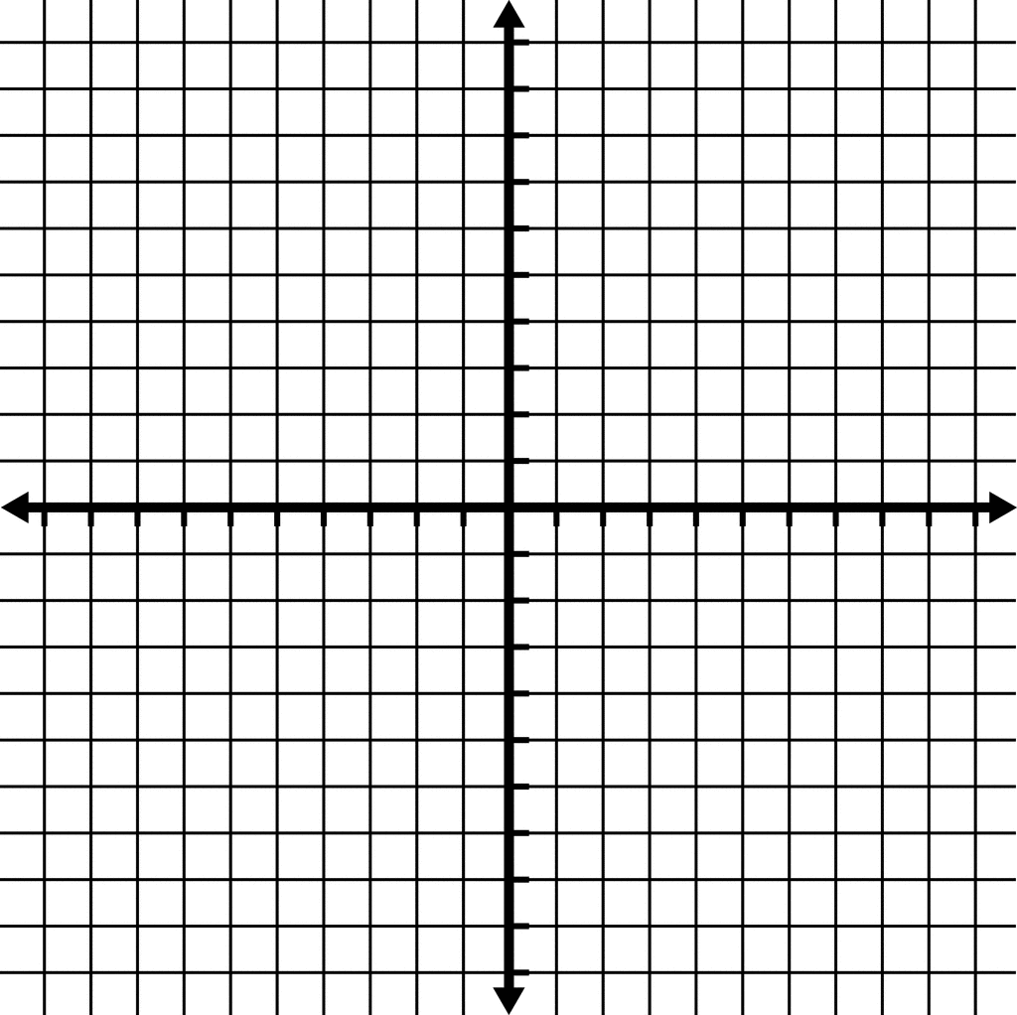
Back of the house
G
A
R
D
E
N
Pond
Deck
Note: each tick mark represents a 1 foot distance
1) Determine one possible location to place the stake (center of the circle) in each of the quadrants of the yard so that Fido can run in the greatest circle possible with a leash 3 feet long. Write below to represent your circles:

2) Where could you place the stake so that Fido could run with a 4 feet long leash in three of the quadrants? Write equations below to represent your circles:

3) Where could you place the stake if the leash was 5 feet long? Write the equations to represent your circles below

4) Could you find a location for a leash 6 feet long? Why or why not?

