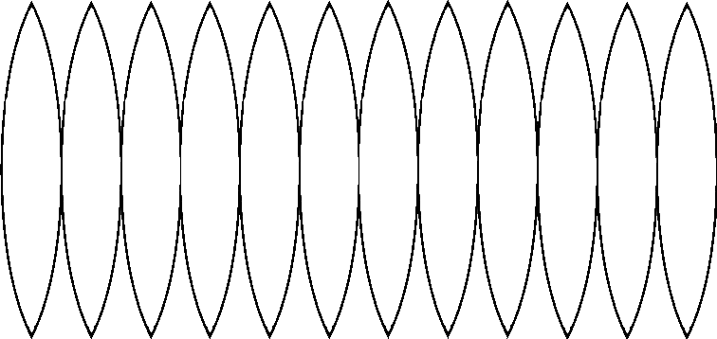

http://gwydir.demon.co.uk/jo/solid/other.htm

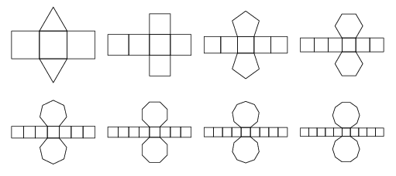
http://mathworld.wolfram.com/Prism.html
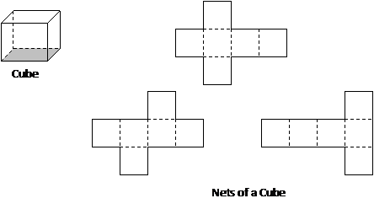
http://www.onlinemathlearning.com/surface-area.html

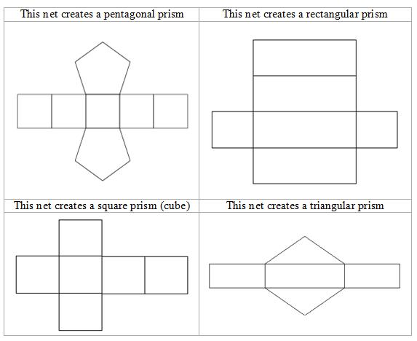
http://moodle.tbaisd.org/mod/book/print.php?id=51648#ch51135

http://www.onlinemathlearning.com/geometry-nets.html

