Food Web Activities
Production/Grazing/Predation Game
Teacher Instructions
Objective
Students will be able to describe the dynamics of a simple food chain with three trophic levels. They will learn that the population size depends on the abundance of lower trophic levels and the rate of growth and predation.
Materials and Supplies
For each group:
6 game boards (page with nutrients)
6 pages of each trophic level, copied onto colored paper
(diatoms on green paper, krill on yellow paper, whale on purple paper)
stop watch
scissors
Standards
LACC.910.RST.1.1 : Cite specific textual evidence to support analysis of science and technical texts, attending to important distinctions the author makes and to any gaps or inconsistencies in the account.
LACC.910.RST.1.3: Follow precisely a complex multistep procedure when carrying out experiments, taking measurements, or performing technical tasks, attending to special cases or exceptions defined in the text.
LACC.910.RST.2.4: Determine the meaning of symbols, key terms, and other domain-specific words and phrases as they are used in a specific scientific or technical context relevant to grades 9–10 texts and topics.
LACC.910.RST.3.7: Translate quantitative or technical information expressed in words in a text into visual form (e.g., a table or chart) and translate information expressed visually or mathematically (e.g., in an equation) into words.
LACC.910.WHST.3.9: Draw evidence from informational texts to support analysis, reflection, and research.
SC.912.N.1.1: Define a problem based on a specific body of knowledge, for example: biology, chemistry, physics, and earth/space science
SC.912.N.1.6: Describe how scientific inferences are drawn from scientific observations and provide examples from the content being studied.
SC.912.L.18.7: Identify the reactants, products, and basic functions of photosynthesis.
SC.912.L.17.13: Discuss the need for adequate monitoring of environmental parameters when making policy decisions.
SC.912.L.17.20: Predict the impact of individuals on environmental systems and examine how human lifestyles affect sustainability.
SC.912.L.17.8: Recognize the consequences of the losses of biodiversity due to catastrophic events, climate changes, human activity, and the introduction of invasive, non-native species.
SC.912.L.17.9: Use a food web to identify and distinguish producers, consumers, and decomposers. Explain the pathway of energy transfer through trophic levels and the reduction of available energy at successive trophic levels.
Background
In a simple food chain with three trophic levels, there are primary producers, grazers, and predators. The population size of each level depends on the abundance of nutrients or prey, and growth, feeding, and reproduction rates. In this activity, the trophic levels are from an upwelling ecosystem such as the Gulf of the Farallones with phytoplankton (diatoms), zooplankton (krill), and whales. For simplicity, the production rate is the combination of the growth, feeding, and reproduction rates. Students should play at least two rounds of the game with different production rates. The first round is a steady state system where all three tropic levels continue to grow. In the other rounds, one tropic level will go extinct (crash) due to lack of food and then the other tropic levels will slowly crash.

Fishery management depends on population dynamics models. In this very simple model, there is only one production rate. In fishery models, growth, feeding, and reproduction rates are included separately. As a fish grows, it feeds on different sized food and is prey to different predators. Also, the rates are different at different life stages and are important in determining population size. Population dynamics models are very complex when they account for the changes in a population at different life stages.

Students will learn that the trophic levels depend on each other. When one trophic level decreases, it will affect the abundance of organisms at other trophic levels.
Activity
1. Discuss population dynamics. Students should know that diatoms are the primary producers, krill (grazers) eat diatoms, and whales (predators) eat krill. This is a game to see how trophic levels are dependent on each other. Ecosystems are controlled by the production rate of each trophic level and the nutrient supply. In this game, a steady state system is when all trophic levels are growing and none are limited.

2. Divide students into groups of 4. Pass out all supplies to each group.

3. Assign each person to a trophic level, and one person should be in charge of the stopwatch.
Nutrients (NO₃⁻¹= Nitrate, PO₄⁻³= Phosphate) - required for photosynthesis by diatoms
Primary Producers - diatoms - green
Primary Consumers/Grazers - krill - yellow
Secondary Consumers/Predators - whales - purple

4. The page with the nutrients is the game board. The other pages should be cut into squares. Each card represents an abundance of organisms that consumes the abundance of one card of their prey (the lower trophic level). For example, one card of krill represents enough krill to feed one whale. Each group should play at least 2 rounds (Round 1 and a round of either: 2a, 2b, or 2c).

5. Rules:
- Each round lasts exactly 5 minutes.
- To begin, lay down the 6 nutrient sheets on a desk.
- Use the start time and production rate for each trophic level from the chart below.
- The start time is the time at which a trophic level begins growing (start laying down cards).
- The production rate is the combination of the feeding, growing, and reproduction rates. It is the time interval between laying cards down.
- For example in Round 1, primary producers lay down one card at the beginning (t=0) and lay down 1 card every 5 seconds for the entire 5 minutes. Krill (grazers) start after 10 seconds (t=10), and lay down 1 card every 10 seconds. When adding more cards to the board, the population is reproducing and growing.
- Place cards only over their prey (lower trophic level). Do not overlap cards of the same color. Diatoms (green) lay down their cards on the nutrient sheet. Krill (yellow) may only lay down their card (feed) on top of diatoms (green), and whales may only lay down their card (feed) on top of krill (yellow).

 |  | Round 1 |  | Round 2A |  | Round 2B |  | Round 2C
Trophic Level | Card Color | Start Time (s) | Production Rate | Start Time (s) | Production Rate | Start Time (s) | Production Rate | Start Time (s) | Production Rate
Diatoms | Green | 0 | 5 | 0 | 5 | 0 | 5 | 0 | 2
Krill | Yellow | 10 | 10 | 20 | 3 | 10 | 15 | 10 | 5
Whales | Purple | 20 | 30 | 25 | 20 | 20 | 10 | 20 | 10

Going extinct/crashing of a trophic level
This can be confusing, so it is best to be flexible when students say a trophic level has crashed.
- When a card is showing, those organisms are alive, feeding, and reproducing. Once a card has been covered up, the organisms have been eaten and are dead.
- If all the cards of a trophic level are covered up (they have all been eaten), they cannot reproduce or feed.
- That trophic level has gone extinct or crashed.
- If a trophic level cannot feed (lay down any more cards), because there are no more cards of their prey (lower trophic level) uncovered (there is no more food left), then that trophic level has crashed.
- When a trophic level has crashed, record the time and number of cards uncovered for the crashed trophic level.

End of Round
- At the end of 5 minutes, record for each trophic level the number of cards remaining uncovered (still alive and feeding) and/or when the trophic level crashed.

When students are done, they should write their results on the board to compare them with other students’ results and to complete the results table. They should answer the questions about all 4 rounds, rather than just the rounds that they played.

 |  | Round 1 |  | Round 2A |  | Round 2B |  | Round 2C
Trophic Level | Card Color | Crash Time (s) | Number of Cards | Crash Time (s) | Number of Cards | Crash Time (s) | Number of Cards | Crash Time (s) | Number of Cards
Diatoms | Green
Krill | Yellow
Whales | Purple

Remember that this game is just a simplified version of real life. It is modeled after how real populations can affect each other. The rate of laying down cards is the feeding, growing, and reproduction rate.

The following results table has the answers that you should expect. Students will probably get close, but not exactly these answers, depending on how well they followed the rules.

 |  | Round 1 |  | Round 2A |  | Round 2B |  | Round 2C
Trophic Level | Card Color | Crash Time | Number of Cards | Crash Time | Number of Cards | Crash Time | Number of Cards | Crash Time | Number of Cards
Diatoms | Green | - | 31 | 0:44 | 0 | - | 60 | 2:23 | 45
Krill | Yellow | - | 20 | 0:45 | 8 | 0:20 | 0 | - | 30
Whales | Purple | - | 10 | 3:05 | 9 | 0:30 | 1 | - | 29

Answers to student worksheet questions, with more information for the teacher.
- Round 1 is a steady state system. All levels are producing at a rate slower than the trophic level below them. The diatoms have the highest (fastest) rate at 1 card every 5 seconds, the krill are the middle with a rate of 1 card every 10 seconds, and the whales are the lowest (slowest) at a rate of 1 card every 30 seconds.

Round 2A is a primary producer limited system. The krill are producing at a faster rate than the diatoms, so the diatoms go extinct first and then the other levels crash afterwards.

Round 2B is limited by the whales. The whales begin producing before the krill have had time to get going. The diatoms continue to grow through the whole round.

Round 2C is limited by nutrients. The diatoms use up the nutrients before the round is over. The krill and whales continue to feed, but the diatoms do not reproduce anymore.

- The production rate in Round 1 is increased from one trophic level to the next. If this round continued, the diatoms would crash first because they would run out of nutrients.

- Diatoms were eaten, so they could not reproduce (lay another card down), then the krill ran out of food, then the whales. The whales survived longer because their production rate was so much slower than the other levels. Krill were eating at a faster rate than the diatoms were photosynthesizing and growing.

- Steady state could be restored in Round 2A by increasing the rate of the diatom production (lowering the rate to below one card per 3 seconds to one card per 2 seconds) or by decreasing the rate of krill production (making the production rate at one card every 6 seconds).

- Diatom abundance is controlled by . . .
Round 1. diatom production rate and krill production rate
Round 2A. krill production rate
Round 2B. diatom production rate.

- The growth rate of diatoms in Round 2C is limited by nutrients. If this game were to last longer, the krill and whales would go extinct because they would run out of food.

- For this model, it is assumed that the feeding rate, reproduction rate, and growth rate are all one rate. In reality, this is not true. The assumptions surrounding when a tropic level crashes are not realistic. This model is limited in predicting the relationships between feeding rates and reproductive rates of different trophic levels. This model emphasizes the relationship between trophic levels.

Extensions
This will facilitate the incorporation of:
SC.912.L.17.11: Evaluate the costs and benefits of renewable and nonrenewable resources, such as water, energy, fossil fuels, wildlife, and forests.
SC.912.L.17.4: Describe changes in ecosystems resulting from seasonal variations, climate change and succession.
- Students may also model or think about the impacts of increased nutrient levels due to a phosphate spill/leaching due to mining or excessive fertilizer use. All are possibilities for local Florida water ways.
- Have students consider which trophic level would be most impacted by a coastal oil spill and which of the scenarios they would most likely observe.
- Global climate change is resulting in decreased pH levels in the oceans (normal ocean water ~8.0) and increased ocean temperatures. How might these impact the modeled food chain? Have students look at the large food web of the Gulf of Farallones and make predictions on how different organisms may be effected.

Production/Grazing/Predation Game

FARALLONES MARINE SANCTUARY ASSOCIATION
P.O. BOX 29386
SAN FRANCISCO, CA 94129 (415) 561-6625 www.farallones.org

Gulf of the Farallones
s
National Marine Sanctuary
copyright 2002

3 m 3 m 3 m

3 m 3 m 3 m

3 m 3 m 3 m

3 m 3 m 3 m

.1 mm

.1 mm
.1 mm

.1 mm

.1 mm
.1 mm

.1 mm

.1 mm
.1 mm

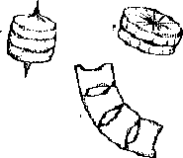
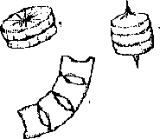
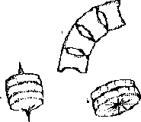
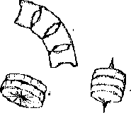
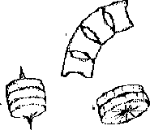
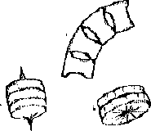
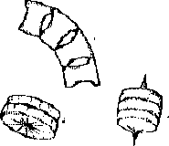
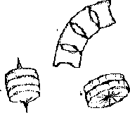
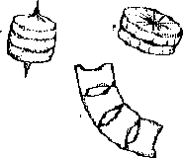
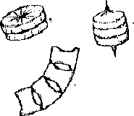
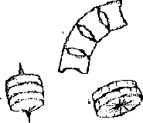
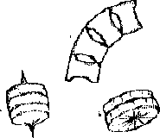
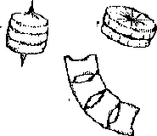
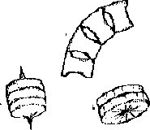
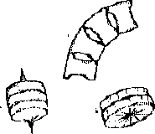
.1 mm
.1 mm .1 mm

1 cm
1 cm

1cm

1 cm
1 cm
1cm

1 cm

1 cm
1cm

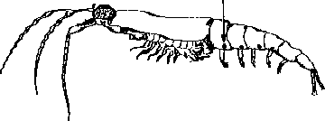
1 cm
1 cm
1cm

PO -3
4
3
3
PO -3
PO -3

NO -
4
4
3
NO -
NO -

PO -3
4
3

PO -3
4
PO -3

NO -
3

NO -
4
3
NO -

PO -3
4

NO -
3

PO -3
4

NO -
3
PO -3

NO -
4
3

PO -3
4

NO -
3
PO -3

NO -
4
3
PO -3

NO -
4
3

Population Dynamics Game Student Worksheet

 |  | Round 1 |  | Round 2A |  | Round 2B |  | Round 2C
Trophic Level | Card Color | Start Time | Production Rate | Start Time | Production Rate | Start Time | Production Rate | Start Time | Production Rate
Diatoms | Green | 0 | 5 | 0 | 5 | 0 | 5 | 0 | 2
Krill | Yellow | 10 | 10 | 20 | 3 | 10 | 15 | 10 | 5
Whales | Purple | 20 | 30 | 25 | 20 | 20 | 10 | 20 | 10

RESULTS
 |  | Round 1 |  | Round 2A |  | Round 2B |  | Round 2C
Trophic Level | Card Color | Crash Time | Number of Cards | Crash Time | Number of Cards | Crash Time | Number of Cards | Crash Time | Number of Cards
Diatoms | Green
Krill | Yellow
Whales | Purple

- What is the abundance of each tropic level at the end of the game for all four rounds? Which levels are growing at the end of the game for all four rounds?

- Round 1 is a steady state system. Compare the production rates of the trophic levels. Predict what would happen to the diatoms and whales if this game were to run another 5 minutes?

- Why did all the trophic levels crash in Round 2A?

- Name two ways a steady state could be restored for Round 2A?

- Compare the abundance of diatoms alive at the end of Rounds 1, 2A, and 2B. What controls the abundance of diatoms in each round?

- What limits the growth of the diatoms in Round 2C? Predict what would happen to the diatoms and whales if this game were to run another 5 minutes?

- What are some of the assumptions and limitations of this model?

