CIS Lesson
Biotechnology
“Extreme Science”

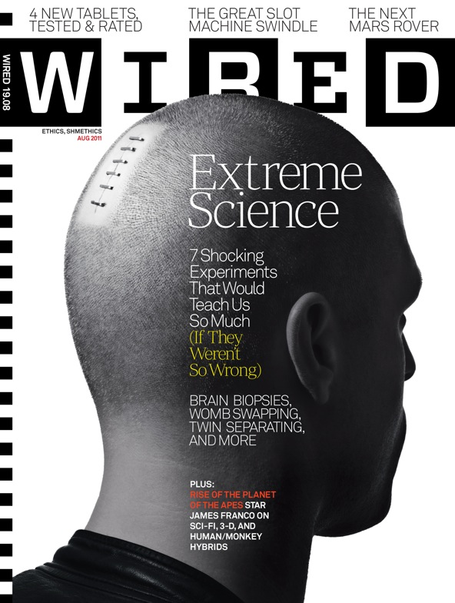

SC.912.L.16.10: Evaluate the impact of biotechnology on the individual, society and the environment, including medical and ethical issues.

CIS Lesson
Biotechnology

“Extreme Science”
Addresses:
- SC.912.L.16.10: Evaluate the impact of biotechnology on the individual, society and the environment, including medical and ethical issues.

1. Hook:

- The Island – 2005 “What are we?”
http://www.youtube.com/watch?v=pTbelq2dtKg&list=PL9A889D37856A4863

- Gattaca - 1997 “A visit to the geneticist”
http://www.youtube.com/watch?v=lP1cCjBkWZU

- Jurassic Park – 1993 “Welcome to Jurassic Park”
http://www.youtube.com/watch?v=PJlmYh27MHg

- Jurassic Park DNA
http://www.youtube.com/watch?v=mDTaykXudVI

2. Question #1: Prediction Question
Predict bioethical issues that may arise during scientific research due to the availability of new biological “tools” and our ever deepening understanding of the biological world.

3. Pass out Article

4. Vocabulary

5. Text Marking

E = Experiment (What is each experiment testing?)
B = Benefits of the experiment
R = Risks of the Experiment

6. Question #2: Text Based Question
What are the bioethical issues that may arise during scientific research due to the availability of new biological “tools” and our ever deepening understanding of the biological world?

7. Note-taking:
Should science be allowed to perform these extreme experiments; do the benefits of “extreme science” outweigh the risks?

8. Vote:
Should science be allowed to perform these extreme experiments; do the benefits of “extreme science” outweigh the risks?

 | Individual | Group | Recount Individual
Experiment is unethical
Experiment mentally damaging to subjects
Experiment physically damaging to subjects
Experimental data could save lives/develop treatments
Experimental data will increase scientific understanding
*Project on Board.

9. Debate:
An individual representing each position presents a persuasive argument in favor of their position. A recount is conducted to allow students to change their vote.

10. Written Response:
Choose one experiment from the readings you feel strongly about (in favor of or against). Using text based evidence, convince a board of scientists why this experiment should or should not be performed. Include a justification of the risks and the benefits of performing this experiment. Lay out your position with a thesis statement that is supported with evidence from the provided text. Feel free to bring in additional research from other sources (be sure to cite those sources; 3 to 4 paragraphs).

CIS Lesson
Biotechnology
“Extreme Science”
#1: Predict bioethical issues that may arise during scientific research due to the availability of new biological “tools” and our ever deepening understanding of the biological world.

#2: What are the bioethical issues that may arise during scientific research due to the availability of new biological “tools” and our ever deepening understanding of the biological world?

Seven Creepy Experiments That Could Teach Us So Much (If They Weren’t So Wrong)
WIRED Magazine – August 2011

1  2  3  4  5  6  7  8  9  10  11  12  13  14  15  16  17  18  19  20  21  22  23  24  24  25  26  27  28  29  30  31  32  33  34 | When scientists violate moral taboos, we expect horrific consequences. It’s a trope in our storytelling that goes back at least to Mary Shelley’s Frankenstein: However well-intentioned our fictional scientists may be, their disregard for ethical boundaries will produce not a peer-reviewed paper in Science but rather a new race of subhuman killers, a sucking wormhole in space-time, or a profusion of malevolent goo.  In the real world, though, matters aren’t so simple. Most scientists will assure you that ethical rules never hinder good research—that there’s always a virtuous path to testing any important hypothesis. But ask them in private, perhaps after a drink or three, and they’ll confess that the dark side does have its appeal. Bend the rules and some of our deepest scientific conundrums could be elucidated or even resolved: nature versus nurture, the causes of mental illness, even the mystery of how humans evolved from monkeys. These discoveries are just sitting out there, waiting for us to find them, if only we were willing to lose our souls.  What follows are seven creepy experiments—thought experiments, really—that show how contemporary science might advance if it were to toss away the moral compass that guides it. Don’t try these at home—or anywhere, for that matter. But also don’t pretend you wouldn’t like to learn the secrets that these experiments would reveal.  Separating Twins  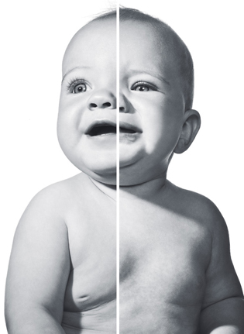  The Experiment: Split up twins after birth—and then control every aspect of their environments.  The premise:  In the quest to tease out the interplay of nature and nurture, researchers have one obvious resource: identical twins, two people whose genes are nearly 100 percent the same. But twins almost always grow up together, in essentially the same environment. A few studies have been able to track twins separated at a young age, usually by adoption. But it’s impossible to control retroactively for all the ways that the lives of even separated twins are still related. If scientists could control the siblings from the start, they could construct a rigorously designed study. It would be one of the least ethical studies imaginable, but it might be the only way (short of cloning humans for research, which is arguably even less ethical) that we’d ever solve some big questions about genetics and upbringing.  How it works:  Expectant mothers of twins would need to be recruited ahead of time so the environments of each sibling could differ from the moment of birth. After choosing what factors to investigate, researchers could construct test homes for the children, ensuring that every aspect of their upbringing, from diet to climate, was controlled and measured.  The payoff:  Several disciplines would benefit enormously, but none more than psychology, in which the role of upbringing has long been particularly hazy. Developmental psychologists could arrive at some unprecedented insights into personality—finally explaining, for example, why twins raised together can turn out completely different, while those raised apart can wind up very alike. —Erin Biba  Brain Sampling  The Experiment: Remove brain cells from a live subject to analyze which genes are switched on and which are off.  You might donate blood or hair for scientific research, but how about a tiny slice of your brain—while you're still alive?  Photo: Bartholomew Cooke  The premise:  You might donate blood or hair for scientific research, but how about a tiny slice of your brain—while you’re still alive? Medical ethics wouldn’t let you consent to that even if you wanted to, and for good reason: It’s an invasive surgery with serious risks. But if enough healthy patients agreed, it could help answer a huge question: How does nurture affect nature, and vice versa? Although scientists recognize in principle that our environment can alter our DNA, they have few documented examples of how these so-called epigenetic changes happen and with what consequences.  Animal studies suggest the consequences could be profound. A 2004 McGill University study of lab rats found that certain maternal behaviors can silence a gene in the hippocampi of their pups, leaving them less able to handle stress hormones. In 2009, a McGill-led team got a hint of a similar effect in humans: In the brains of dead people who had been abused as children and then committed suicide, the analogous gene was largely inhibited. But what about in living brains? When does the shift happen? With brain sampling, we might come to understand the real neurologic toll of child abuse and potentially a great deal more than that.  How it works:  Researchers would obtain brain cells just as a surgeon does when conducting a biopsy: After lightly sedating the patient, they would attach a head ring with four pins, using local anesthetic to numb the skin. A surgeon would make an incision a few millimeters wide in the scalp, drill a small hole through the skull, and insert a biopsy needle to grab a tiny bit of tissue. A thin slice would be sufficient, since you need only a few micrograms of DNA. Assuming no infection or surgical error, damage to the brain would be minimal.  The payoff:  Such an experiment might answer some deep questions about how we learn. Does reading turn on genes in the prefrontal cortex, the site of higher-order cognition? Does spending lots of time at a batting cage alter the epigenetic status of genes in the motor cortex? Does watching Real Housewives alter genes in whatever brain you have left? By correlating experiences with the DNA in our heads, we could better understand how the lives we lead wind up tinkering with the genes we inherited. —Sharon Begley  Embryo Mapping  The Experiment: Insert a tracking agent into a human embryo to monitor its development.  Photo: Bartholomew Cooke  Image based on photo by photo researchers  The premise:  These days, expectant mothers undergo elaborate tests to make sure their fetus is normal. So, would any of them allow scientists to exploit their future offspring as a science project? Not likely. But without that sort of radical experimentation, we may never fully understand the great remaining mystery of human development: how a tiny clump of cells transforms into a fully formed human being. Today, researchers have the tools to answer that question in principle, thanks to new technology that allows for the tracking of cells’ genetic activity over time. If ethics weren’t an issue, all they would need was a willing subject—a mother who would let them use her embryo as a guinea pig.  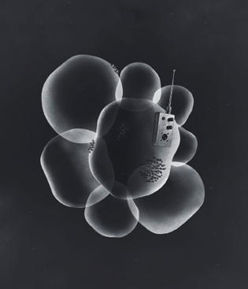  How it works:  To trace the activity of different genes within an embryonic cell, researchers could use a synthetic virus to insert a “reporter” gene (green fluorescent protein, for example) that was visually detectable. As that cell divided and differentiated, researchers could actually observe how genes turned on and off at various points in development. This would let them see which developmental switches transform embryonic stem cells into hundreds of types of specialized adult cells—lung, liver, heart, brain, and so on.  The payoff:  A fully mapped embryo would give us, for the first time, a front-row seat for the making of a human being. That information could help us direct the evolution of stem cells to repair cellular damage and treat disease (say, by inserting a healthy pool of neurons into the brain of a patient with Parkinson’s disease). Comparing the details of human embryonic development to that of other species—similar mapping has already been done on mice, for example—might also reveal the differences in genetic expression that contribute to complex human attributes such as language. But the risks of human embryo mapping are too great to even consider performing it. Not only would the mapping process risk terminating the pregnancy, the viral vector used to insert the reporter gene might disrupt the embryo’s DNA and lead, ironically, to developmental defects. —Jennifer Kahn  Optogenetics  The Experiment: Use beams of light to control the activity of brain cells in conscious human beings.  The premise:  May I cut open your skull and implant some electronic gizmos in there? Before you say no, listen to what science might get out of the deal. The brain is a nearly infinite knot of electrical connections, and figuring out the purpose of any given circuit is a massive challenge. Much of what we do know comes from studying brain injuries, which let us crudely infer the function of various areas based on the apparent effects of the wounds. Conventional genetic approaches, in which particular genes are chemically disabled or mutated, are more precise—but those techniques take hours or even days to influence the activity of cells, making it hard to trace the impact on mental processes. To really map the brain, scientists will need a tool that is precise but also fast.  How it works:  Optogenetics is an experimental method being used with great success in mice. Researchers have engineered a benign virus that, when injected into the brain, makes the ion channels—the switches that turn cells on and off—responsive to light. By flashing focused beams into brain tissue (usually with hair-width fiber-optic strands), researchers can selectively increase or decrease the firing rate of these cells and watch how subjects are affected. Unlike conventional genetic approaches, optogenetic flashes alter neural firing within milliseconds. And by aiming at specific circuits in the brain, it’s possible to test theories with great precision.  The payoff:  One human brain, when decked out for optogenetic research, would yield unparalleled insight into the workings of the mind. Just imagine if we could silence a few cells in the right prefrontal cortex and make self-awareness disappear. Or if shining a light in the visual cortex prevented us from recognizing the face of a loved one. Ideally, the effects would be only temporary: Once the light was turned off, those deficits would disappear. Such experiments would give us our first detailed understanding of causality in the cortex, revealing how 100 billion neurons work together to endow us with all the impressive talents we take for granted. —Jonah Lehrer  Womb Swapping  The Experiment: Switch the embryos of obese women with those of thin women.  The premise:  In vitro fertilization is an expensive and risky procedure as it is. So it’s hard to imagine that any mother in an IVF program would ever be willing to swap embryos, entrusting her progeny to another womb while gestating someone else’s child herself. But such an act of scientific selflessness could spawn some truly significant breakthroughs. Why? For all that we don’t understand about epigenetics—the way that our genes are altered by our environment—the trickiest problem is this: Many of the most important epigenetic influences happen while we’re in the womb.  A classic example is obesity. Studies have shown that obese women tend to have overweight children, even before dietary factors kick in. Trouble is, nobody knows how much of that is a product of genes—innate, inherited variations—or epigenetics.  How it works:  The experiment would be the same as regular in vitro fertilization, except the fertilized egg of an obese mother would be transferred to the womb of a skinny mother, and vice versa.  The payoff:  We would know with much more certainty whether the roots of obesity were primarily genetic or epigenetic—and similar studies could probe other traits. For example, a Canadian team is currently undertaking a massive study, the Maternal-Infant Research on Environmental Chemicals, to isolate the effects of in utero exposure to toxins on a child’s genes. With embryo swaps at scientists’ disposal, that task wouldn’t require statistical guesswork. The answer would be clear as day—even if the ethics were profoundly murky. —Jennifer Kahn  Toxic Heroes  The Experiment: Test each new chemical on a wide range of human volunteers before it comes on the market.  The premise:  Under current US regulations, we’re all de facto test subjects for a whole range of potential toxins. So why not recruit volunteers to try out chemicals for us? Even with informed consent, medical ethicists would recoil at that idea. But it would almost certainly save lives over time.  To comply with the US Toxic Substances Control Act, manufacturers turn to testing labs, which expose animals—usually rodents—to high levels of the chemical in question. But just because a mouse survives a test doesn’t mean that humans will. The only studies we can perform on people are observational: tracking the incidence of adverse effects in those we know to have been exposed. But these studies are fraught with problems. When researchers can find high levels of exposure—for example, workers in factories that make or use the chemical—the number of subjects is often too small to yield reliable results. And with broader-based studies, it becomes extremely difficult to tease out one chemical’s effect, since we’re all exposed to so many toxins every day.  How it works:  Perform all the standard safety tests required by the Toxic Substances Control Act on humans instead of animals. To do so, we’d need to recruit volunteers of varying races and health levels—ideally hundreds for each substance.  The payoff:  Toxicology is currently a guessing game. Just think of the controversy over bisphenol A, about which the studies of effects in humans are maddeningly inconclusive. Testing chemicals extensively on groups of people would provide a much more accurate picture of how a given chemical affected us—data that would inform regulators and be shared with the public to help people make their own decisions. An ancillary victory: no more conflicting news reports about what is and isn’t good for you. —Erin Biba  Ape Man  The Experiment:Cross-breed a human with a chimpanzee.  This forbidden experiment would help illuminate how two species with such similar genomes could be so different.  Photo: Bartholomew Cooke  The premise:  The great biologist Stephen Jay Gould called it “the most potentially interesting and ethically unacceptable experiment I can imagine.” The idea? Mating a human with a chimp. His interest in this monstrosity grew out of his work with snails, closely related species of which can display wide variation in shell architecture. Gould attributed this diversity to a few master genes, which turn on and off the shared genes responsible for constructing the shells. Perhaps, he speculated, the large visible differences between humans and apes were also a factor of developmental timing. He pointed out that adult humans have physical traits, such as larger craniums and wide-set eyes, that resemble infant chimpanzees, a phenomenon known as neoteny—the retention of juvenile traits in adults. Gould theorized that over the course of evolution, a tendency toward neoteny might have helped give rise to human beings. By watching the development of a half-human, half-chimp, researchers could explore this theory in a firsthand (and truly creepy) way.  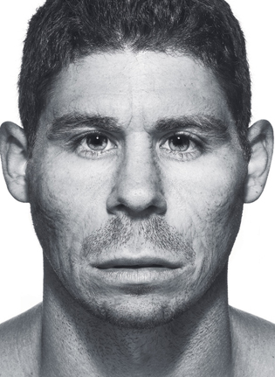  How it works:  It would probably be frighteningly easy: The same techniques used for in vitro fertilization would likely yield a viable hybrid human-chimp embryo. (Researchers have already spanned a comparable genetic gap in breeding a rhesus monkey with a baboon.) Chimps have 24 pairs of chromosomes, and humans 23, but this is not an absolute barrier to breeding. The offspring would likely have an odd number of chromosomes, though, which might make them unable to reproduce themselves. As for the gestation and birth, it could be done the natural way. Chimpanzees are born slightly smaller than humans, on average—around 4 pounds—and so comparative anatomy would argue for growing the embryo in a human uterus.  The payoff:  Gould’s idea about neoteny remains controversial, to say the least. “It got a lot of scrutiny and has been disproved in many ways,” says Daniel Lieberman, a Harvard professor of human evolutionary biology. But Alexander Harcourt, professor emeritus of anthropology at UC Davis, regards neoteny as “still a viable concept.” This forbidden experiment would help to resolve that debate and, in a broader sense, illuminate how two species with such similar genomes could be so different. Its outcome would take biologists deep into the origin of the species we care about most: ourselves. Let’s just hope we can find a less disturbing route to get there. —Jerry Adler
* http://archive.wired.com/magazine/19-08/

Directed Note-Taking

Directions: Record notes containing the most important information relevant to the guiding question.
Extreme Science
(Text is on handout)

Guiding Question: Should science be allowed to perform these extreme experiments; do the benefits of “extreme science” outweigh the risks?

Do your questions pertain to any of the categories to the right? If yes, please put a check.

Check Relevant Categories

Page/  Paragraph# | Notes | Example of Extreme Science | Experiment mentally damaging to subjects | Experiment physically damaging to subjects | Experimental data could save lives/develop treatments | Experimental data will increase scientific understanding

Page/  Paragraph# | Notes | Example of Extreme Science | Experiment mentally damaging to subjects | Experiment physically damaging to subjects | Experimental data could save lives/develop treatments | Experimental data will increase scientific understanding

Written Response:
Choose one experiment from the readings you feel strongly about (in favor of or against). Using text based evidence, convince a board of scientists why this experiment should or should not be performed. Include a justification of the risks and the benefits of performing this experiment. Lay out your position with a thesis statement that is supported with evidence from the provided text. Feel free to bring in additional research from other sources (be sure to cite those sources; 3 to 4 paragraphs).

