Cone Volume Activity Notes

Calculus Connection: Cone Formula
- This note explains the precise derivation of the formula for a cone by rotating a line segment about the x-axis.
http://mathforum.org/library/drmath/view/51718.html

Details: Create a cone by rotating a line about the x-axis. Let the radius of the base of the cone be a, and the height of the cone be h. Then the line which will be rotated is $y=\frac{a}{h} x$ . (Drawn with GeoGebra)

To find the exact volume of the cone, start with the volume of one slice of the cone perpendicular to the x-axis of width$Δx$. For small $Δx$ this volume will be approximately$π {\left(\frac{a}{h}x\right)}^{2}Δx$, since the radius of an arbitrary slice is $\frac{a}{h}x$. Next, integrate this formula from 0 to h (using the Fundamental Theorem of Calculus to move from a sum of slices to the exact volume), to capture the volume of the entire cone.

$\lim_{n→∞}{π\sum_{i=1}^{n}{{\left(\frac{a}{h}x_{i}\right)}^{2}Δx_{i}}}$

$$π\int_{0}^{h}{ \frac{a^{2}}{h^{2}}x^{2}dx}$$
$$= π \frac{a^{2}}{h^{2}} {\left[\frac{1}{3} x^{3}\right]}_{0}^{h}$$
$=\frac{π}{3}a^{2}h$

Calculus Formula: Pyramid Formula
- This note explains the precise derivation of the formula for a pyramid using the three-dimensional expansion of the technique of estimating the area under a curve in two-dimensional space with rectangles and taking the limit as the number of rectangles of uniform width goes to infinity.
http://mathforum.org/library/drmath/view/53646.html

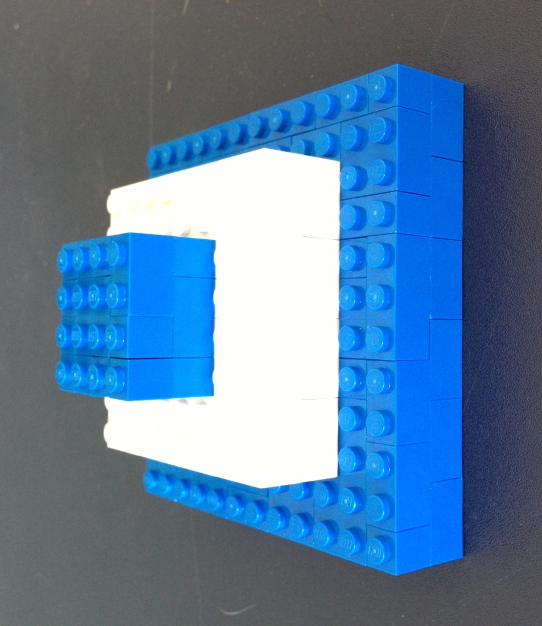

Consider this structure, which is a pyramid made up of three steps. The top step has side length $a_{1}$ and the height is $b_{1}$. The volume of this step is $a_{1}^{2}b_{1}$.
The next step has four blocks the same size as the top step and the bottom step has nine.
The formula for the volume of the entire shape is $a_{1}^{2}b_{1} (1^{2}+2^{2}+3^{2})$.
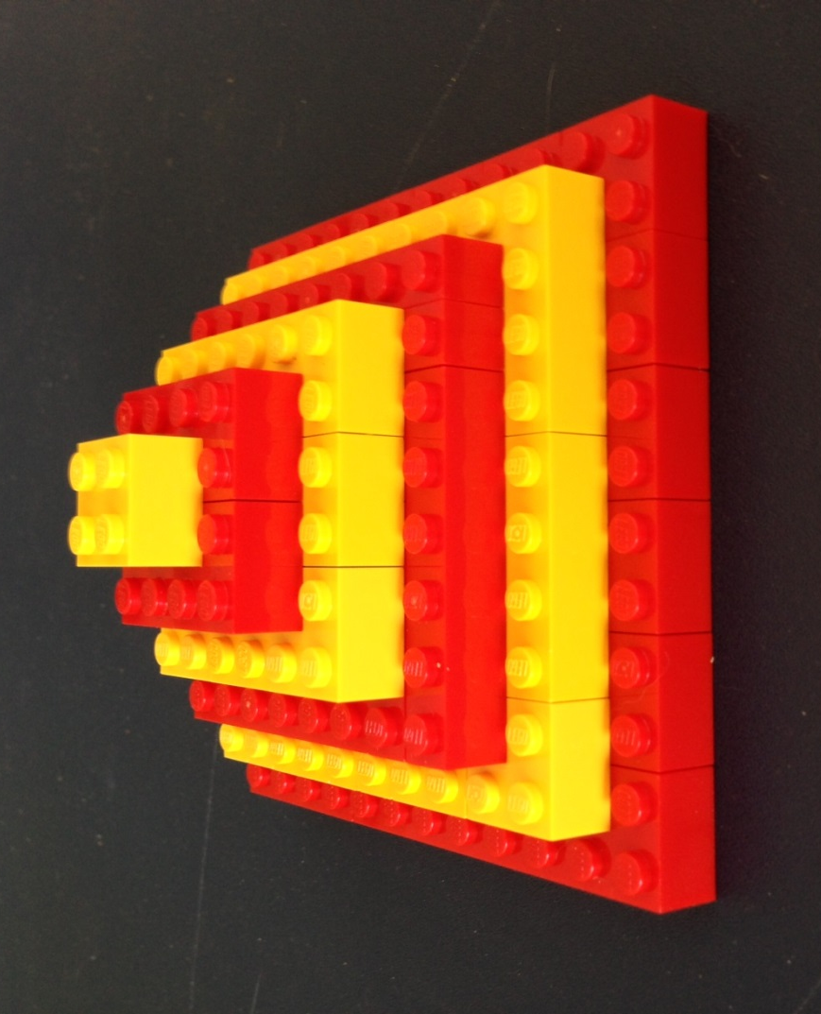

Now consider a refinement of the previous pyramid. This step-pyramid has six steps, with the same base area as the previous pyramid, and the same height.

The volume of the top step is $a_{2}^{2}b_{2}$.
The total volume of the figure is $a_{2}^{2}b_{2}(1^{2}+2^{2}+…+6^{2})$.

If we continue this refinement, a pyramid with $n$ steps and a top block (the building block) with volume $a_{n}^{2}b_{n}$ , will have a total volume of
$a_{n}^{2}b_{n}(1^{2}+2^{2}+…+n^{2})$.
Important Note: As $n$ increases, both the length of the standard building block, $a_{n},$ and its height, $b_{n} ,$decrease. However, the base area and the height are fixed throughout the refinement process.

The area of the base of the pyramid is $a_{n}^{2}n^{2}=B$ regardless of the number of steps $n$.
(i.e. The building blocks have a base area of $a_{n}^{2}$ and there are $n^{2}$ building blocks on the bottom level.)
The height of the pyramid is $b_{n}n=h$ regardless of the number of steps $n$.

It is known that ${ 1}^{2}+2^{2}+…+n^{2}=n\left(n+1\right)\left(\frac{2n+1}{6}\right)$. (Recall the story of Gauss adding the numbers from 1 to 100 when he was in elementary school by developing a formula.)

Our total volume formula may be transformed as follows:

$$a_{n}^{2}b_{n}\left(1^{2}+2^{2}+…+n^{2}\right)=$$
$$a_{n}^{2}b_{n}\left(n\left(n+1\right)\left(\frac{2n+1}{6}\right)\right)=$$
$$a_{n}^{2}b_{n}\left(\frac{n^{3}}{3}+ \frac{n^{2}}{2}+ \frac{n}{6}\right)=$$
$$a_{n}^{2}b_{n}n^{3}\left(\frac{1}{3}+ \frac{1}{2n}+ \frac{1}{6n^{2}}\right)=$$
$$\left(a_{n}^{2}n^{2}\right)\left(b_{n}n\right)\left(\frac{1}{3}+ \frac{1}{2n}+ \frac{1}{6n^{2}}\right)=$$
$$Bh\left(\frac{1}{3}+ \frac{1}{2n}+ \frac{1}{6n^{2}}\right)$$

Now we take the limit as $n$ goes to infinity, which mathematically represents the process of continuing to refine our step pyramid until it morphs into a smooth pyramid with a square base and triangular sides.
$$\lim_{n→ ∞}{Bh ( \frac{1}{3}+ \frac{1}{2n}+ \frac{1}{6n^{2}}})= \frac{1}{3} Bh$$

