**[MACC.912.G-GPE.1.1:](http://www.cpalms.org/Standards/PublicPreviewBenchmark5627.aspx)** Derive the equation of a circle of given center and radius using the Pythagorean Theorem; complete the square to find the center and radius of a circle given by an equation.

1. Review: Identify the center and radius of the circles with the given equations.

A.  B.  C. 

Center: (7,-2) Center: (0,0) Center: (1,3)

Radius: 10 Radius: 8 Radius: 

2. Given a circle with center (*h*,*k*), radius *r*, and a point (*x*,*y*) on the circle, follow the steps to derive the equation of any circle.

Make a right triangle with hypotenuse *r* by drawing a horizontal line segment from (*h*,*k*) to the right and a vertical line segment from (*x*,*y*) down.

Find the coordinates of the point where the segments intersect. 

Find the lengths of the two legs of the triangle. ,

Write an equation that represents the relationship among the lengths of all three sides.

*Compare your equation with two other groups to verify.



*r*





3. Given the equation , find the center and radius of the circle and graph.



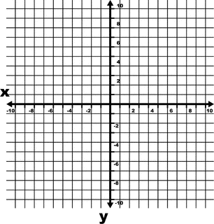





Center = (3,-4); Radius is 3

4. Given the equation , find the center and radius of the circle and graph.









Center = (-2,-1); Radius is 5

5. Given the equation , find the center and radius of the circle.







Center = (-5,7); Radius is 

6. Given a circle with center at the origin and containing the point (5,0). Determine if the point is on the circle. Justify your answer.

If is on the circle with center (0,0) and radius of 5, then the following must be true:



Using substitution, 

, so the point is not on the circle.

7. Determine if the circle with equation intersects *x*-axis. Justify your answer.

The optimal solution would be for students to complete the square so they are applying the concept learned in the lesson.







The center is (0,6) and the radius is . The radius would have to be greater than or equal to 6 to intersect the *x*-axis. This graph does not intersect the *x*-axis.

Note: Some students may try to find the *x*-intercepts by substituting 0 in for *y*. In that case, students would have the equation and use it to justify their answer that the circle does not intersect the *x*-axis.