**[MACC.912.G-GPE.1.1:](http://www.cpalms.org/Standards/PublicPreviewBenchmark5627.aspx)** Derive the equation of a circle of given center and radius using the Pythagorean Theorem; complete the square to find the center and radius of a circle given by an equation.

1. Review: Identify the center and radius of the circles with the given equations.

A.  B.  C. 

Center: ___________ Center: ___________ Center: ___________

Radius: ___________ Radius: ___________ Radius: ___________

2. Given a circle with center (*h*,*k*), radius *r*, and a point (*x*,*y*) on the circle, follow the steps to derive the equation of any circle.

Make a right triangle with hypotenuse *r* by drawing a horizontal line segment from (*h*,*k*) to the right and a vertical line segment from (*x*,*y*) down.

Find the coordinates of the point where the segments intersect.

Find the lengths of the two legs of the triangle.

Write an equation that represents the relationship among the lengths of all three sides.

_____________________________

*Compare your equation with two other groups to verify.



*r*



3. Given the equation , find the center and radius of the circle and graph.

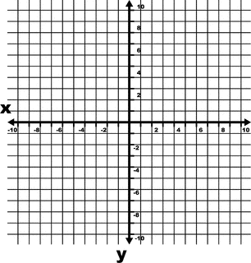

4. Given the equation , find the center and radius of the circle and graph.



5. Given the equation , find the center and radius of the circle.

6. Given a circle with center at the origin and containing the point (5,0). Determine if the point is on the circle. Justify your answer.

7. Determine if the circle with equation intersects *x*-axis. Justify your answer.