Suction Feeding Exercise
Goals:
- Find the volume of the feeding mechanism of the goliath grouper at rest.
- Find the volume of the feeding mechanism of the goliath grouper at maximum expansion.
- Find the area of the mouth of the goliath grouper at maximum expansion.
- Determine the velocity of water flow into the mouth of the goliath grouper using the formula:

$$Velocity=\frac{Change in Volume}{Change in Time}×\frac{1}{Area of Mouth}$$

3-Dimensional Model of the Feeding Mechanism
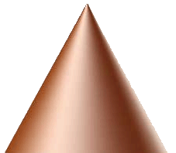
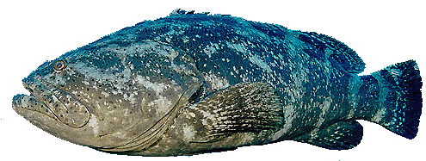
B
A
Mouth

The feeding mechanism of the goliath grouper can be represented by two cones. A full cone (A) extends from beneath the eye to the back of the throat, while a truncated cone (B) extends from beneath the eye to the front opening of the mouth.
2-Dimensional Model of the Feeding Mechanism
A 2-dimensional representation of the feeding mechanism can be used to determine the volume of the goliath grouper’s feeding mechanism, which is the first step in calculating the velocity of water flow into its mouth during suction feeding. To do so, volume calculations must be done with the feeding mechanism at rest and at maximum expansion (Note: an extension is shown to help you find the area of the truncated cone).
b
a
c
d
e
a

B
A

a = radii of cones A and B
b = height of cone A
c = height of truncated portion of cone B
d = radius of extended portion of cone B
e = height of extended portion of cone B

Procedure
*Answers are rounded to one decimal place to match measurements. The π key on the calculator is used instead of 3.14.
Compute answers for the feeding mechanism at rest:
Step 1: Compute the volume of cone A.
$$V=\frac{1}{3}πr^{2}h=\frac{1}{3}π {\left(34.9\right)}^{2}153.6 ≈195,916.4$$

Step 2: Find e (the height of the extended portion of cone B) using similar triangles.

$$\frac{54.3+e}{e}= \frac{34.9}{6.4}$$

$$34.9 e=6.4(54.3+e)$$

$$34.9 e=347.52+6.4 e$$

$$28.5 e=347.52$$

$$e ≈12.2$$

Step 3: Find the total height of cone B (extended portion + truncated portion).
$$54.3+12.2=66.5$$

Step 4: Find the total volume of cone B (extended portion + truncated portion).
$$V=\frac{1}{3}πr^{2}h=\frac{1}{3}π {\left(34.9\right)}^{2}66.5 ≈84,820.6$$

Step 5: Find the volume of the extended portion of cone B, which is also a cone.
$$V=\frac{1}{3}πr^{2}h=\frac{1}{3}π {\left(6.4\right)}^{2}12.2 ≈523.3$$

Step 6: Find the volume of the truncated portion of cone B (total volume – extended portion).
$$84,820.6-523.3=84,297.3$$

Step 7: Find the volume of the feeding mechanism at rest (time t₀), which is the volume of cone A plus the volume of the truncated portion of cone B.
$$195,916.4+84,297.3=280,213.7$$

Step 8: Repeat these steps to find the volume of the feeding mechanism when fully expanded (time t₁).
Volume of cone A: $263,546.5$
Length e: 266.5
Total height of cone B (extended portion + truncated portion): 322.9
Total volume of cone B (extended portion + truncated portion): 527,583.1
Volume of the extended portion of cone B: 296,593.1
Volume of the truncated portion of cone B: 230,990.0
Volume of the feeding mechanism when fully expanded: 494,536.5

Step 9: Calculate the area of the mouth of the goliath grouper when fully expanded.
$$Area=π r^{2}= π {\left(32.6\right)}^{2} ≈3,338.8$$

Step 10: Find the change in volume of the feeding mechanism during the feeding event (volume of feeding mechanism when fully expanded – volume of feeding mechanism at rest).

$$494,536.5-280,213.7=214,322.8$$

Step 11: Compute the velocity of water flow into the mouth given that it took 0.132 s for the goliath grouper to expand its feeding mechanism.

$$Velocity= \frac{Change in Volume}{Change in Time} x \frac{1}{Area of Mouth}$$

$$Velocity= \frac{214,322.8}{0.132} x \frac{1}{3,338.8}$$

$$Velocity ≈486.3 mm/s$$

