1. Compare and contrast the equations for lines, parabolas, and circles. (Identify similarities and differences.)

|  |  |  |
| --- | --- | --- |
| **Lines** | **Parabolas** | **Circles** |
|  |  |  |
|  |  |  |
|  |  |  |
|  |  |  |
|  |  |  |

2. Identify the center and radius of the circles graphed below.

A.  B.  C. 

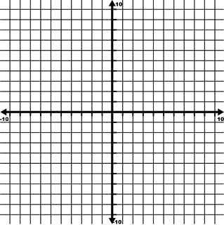  

Center: ___________ Center: ___________ Center: ___________

Radius: ___________ Radius: ___________ Radius: ___________

* Answer the questions on the following page and post to share with your peers.

3. Analyze the equations and graphs in question #2. Form a hypothesis stating how the center and radius of a circle can be found when given an equation.

4. Test your hypothesis by identifying the center and radius of the circles with the given equations:

A.  B.  C. 

Center: ___________ Center: ___________ Center: ___________

Radius: ___________ Radius: ___________ Radius: ___________